**Data Migration and SCD Implementation in Azure SQL Database**

**Creating a Virtual Machine**

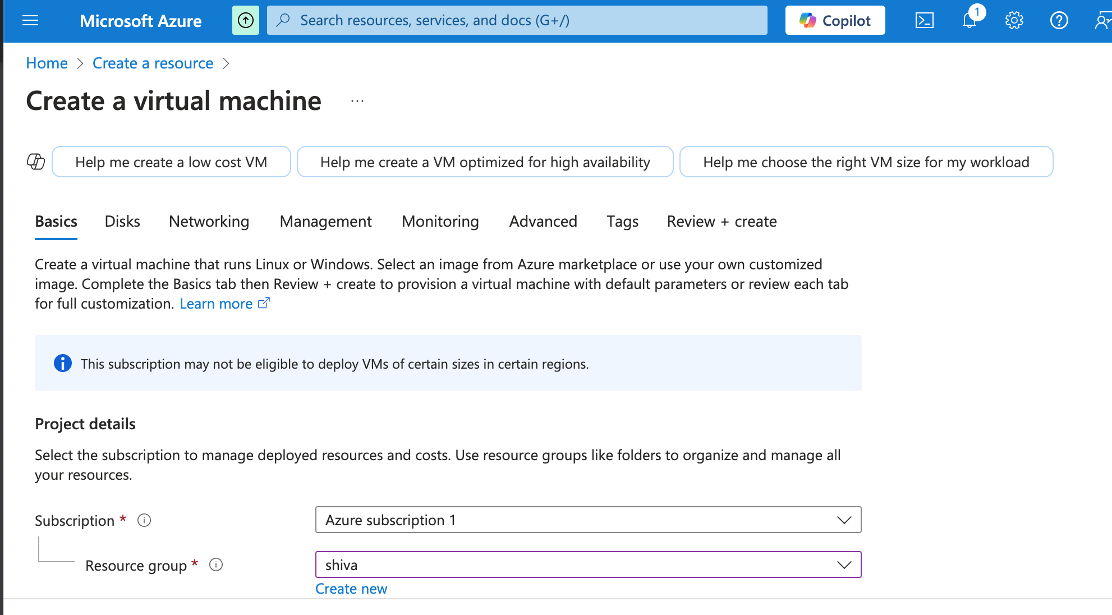 Security type – Standard  
Availability Options – No infrastructure redundancy required

Images – see all images – select Free SQl Server Licence: SQL server 2022 Developer on windows 2022 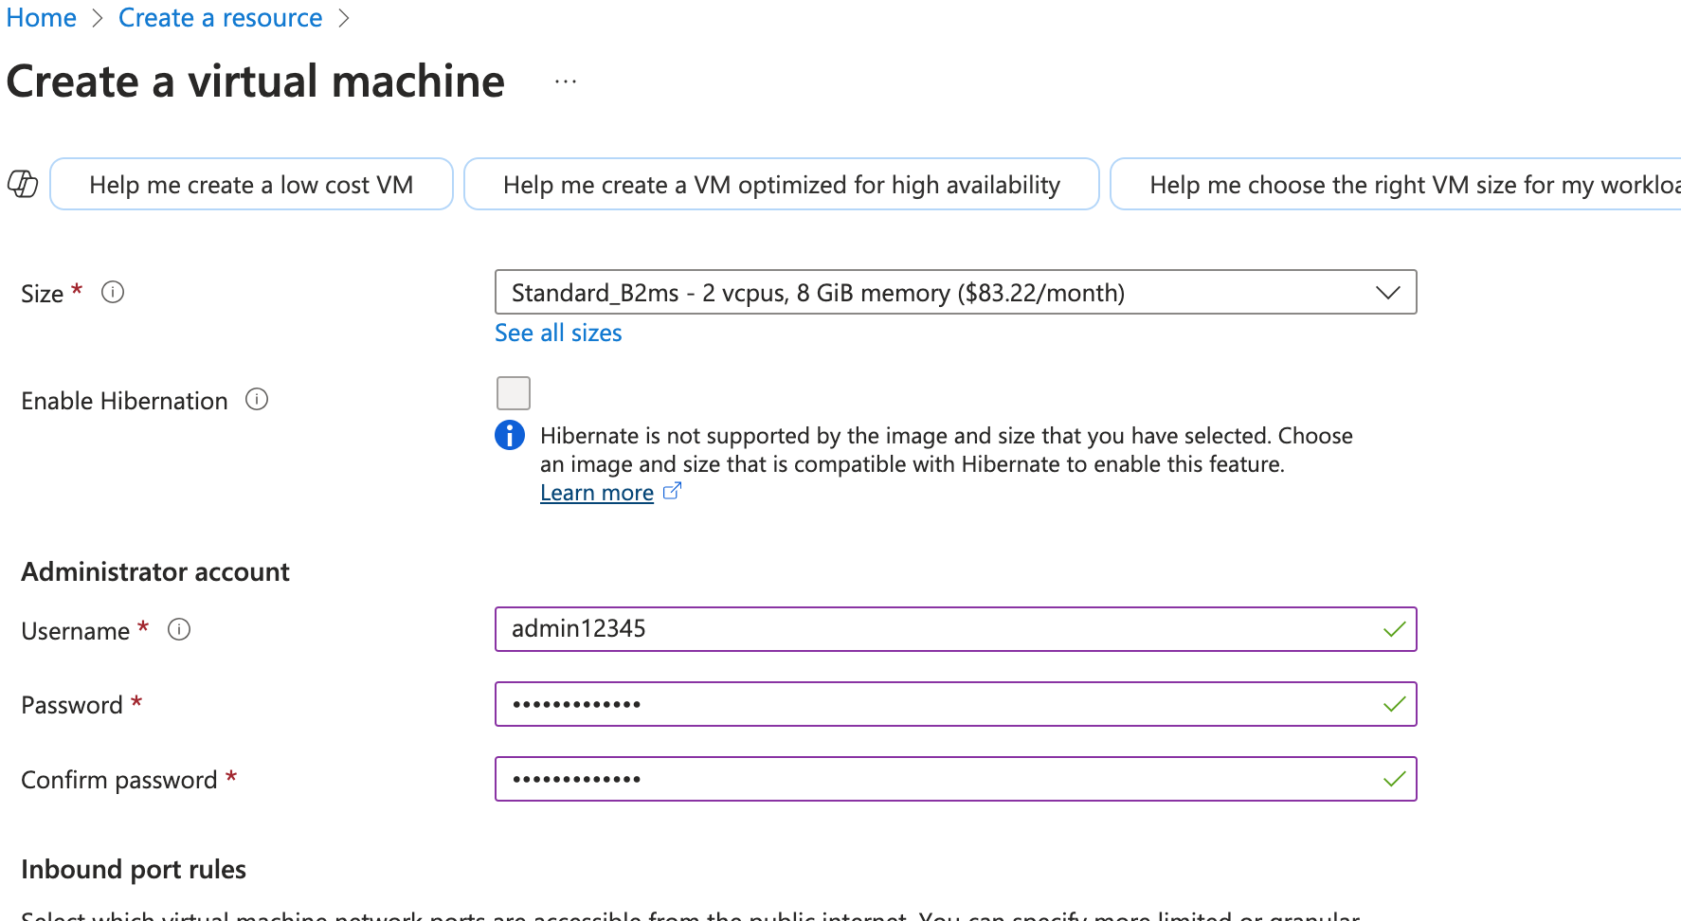 size – see all sizes – standard b2ms (4 vcps and 8gib memory)(hourly)

give admin and password

public inbound ports – all selected ports

select inbound port – RDP port 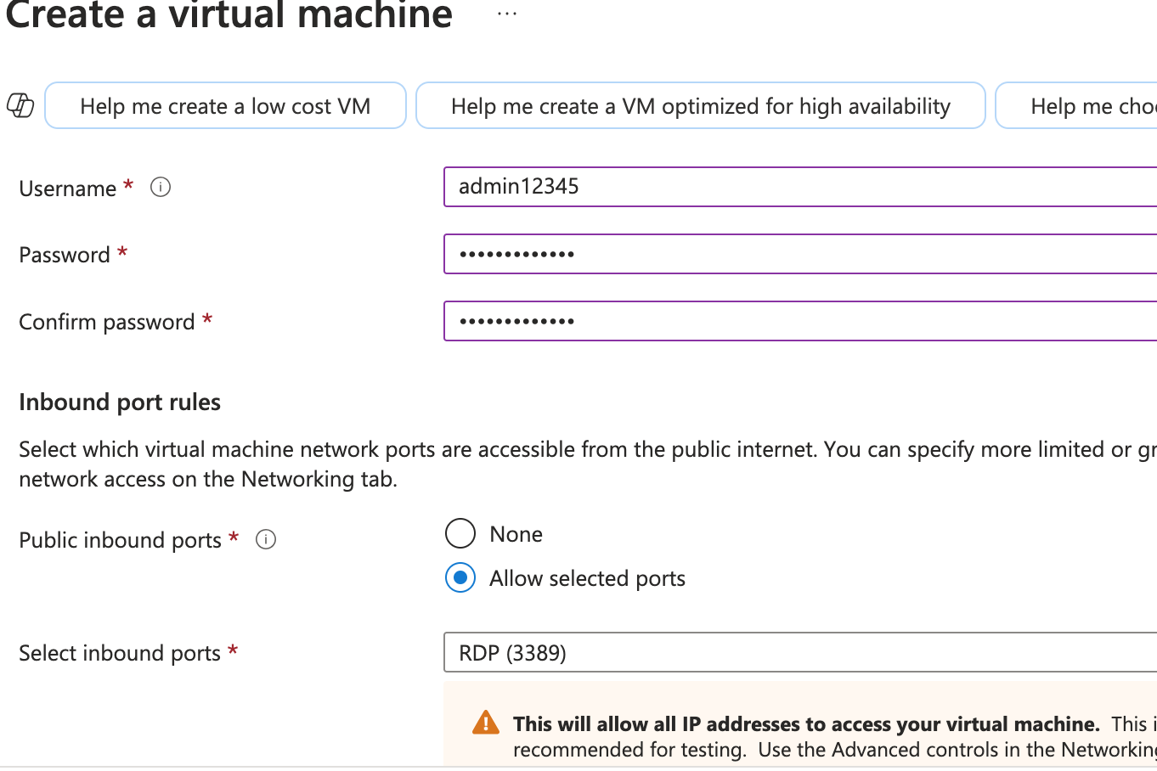 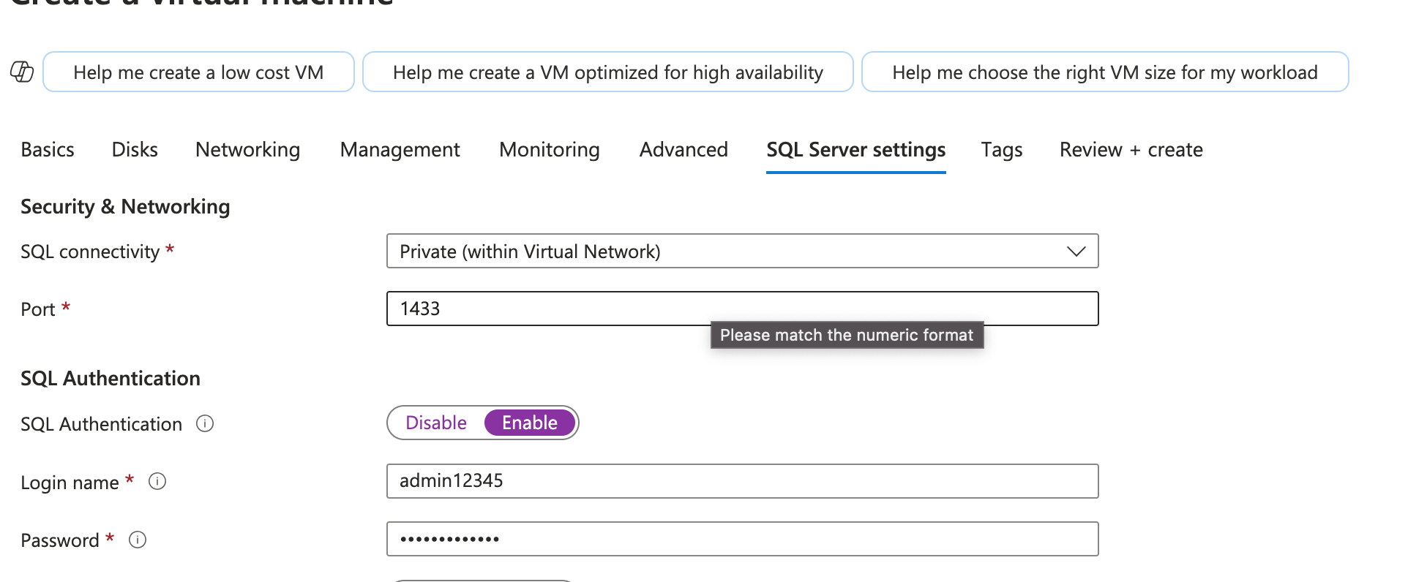 go to SQL Server setting -- enable SQL authentication

Review and deploy

It might take 5-10 mins

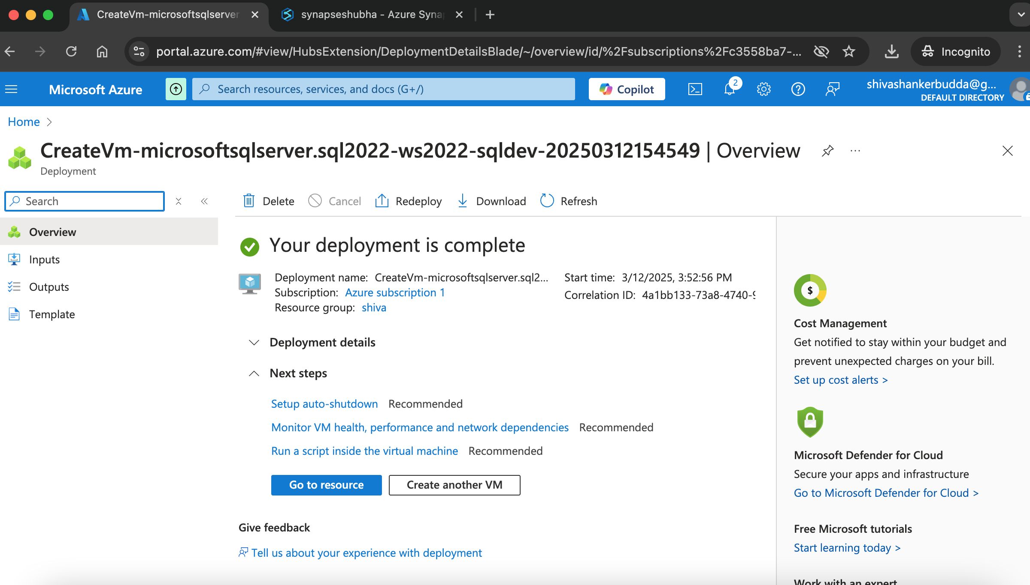 Now go to overview and connect

Download download RDP File 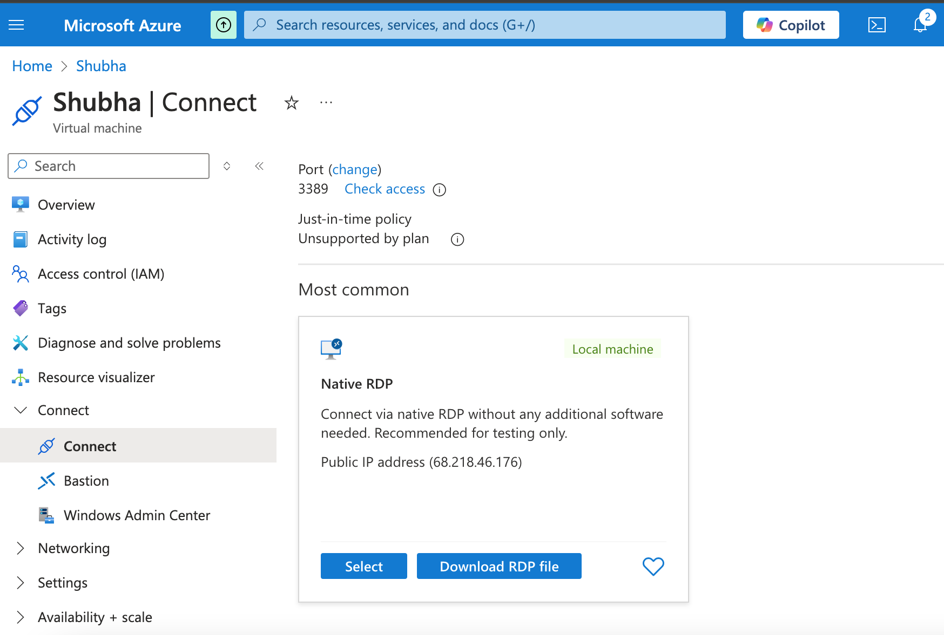

Open the remote machine from download , if ur using mac download window remote desktop from apps

And in server Manager , for IE Enhanced Security Configuration , turn off and user (off) 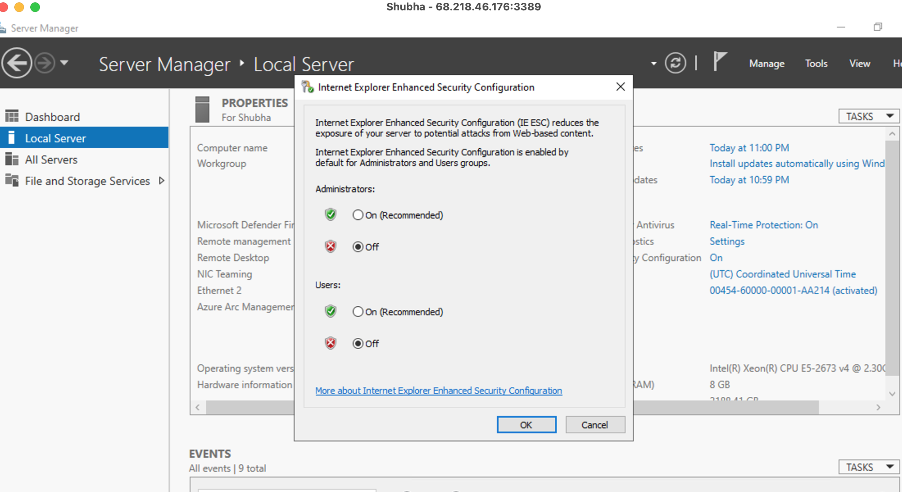 Open Microsoft edge in Vm, and download Integration Runtime 5.5 latest version

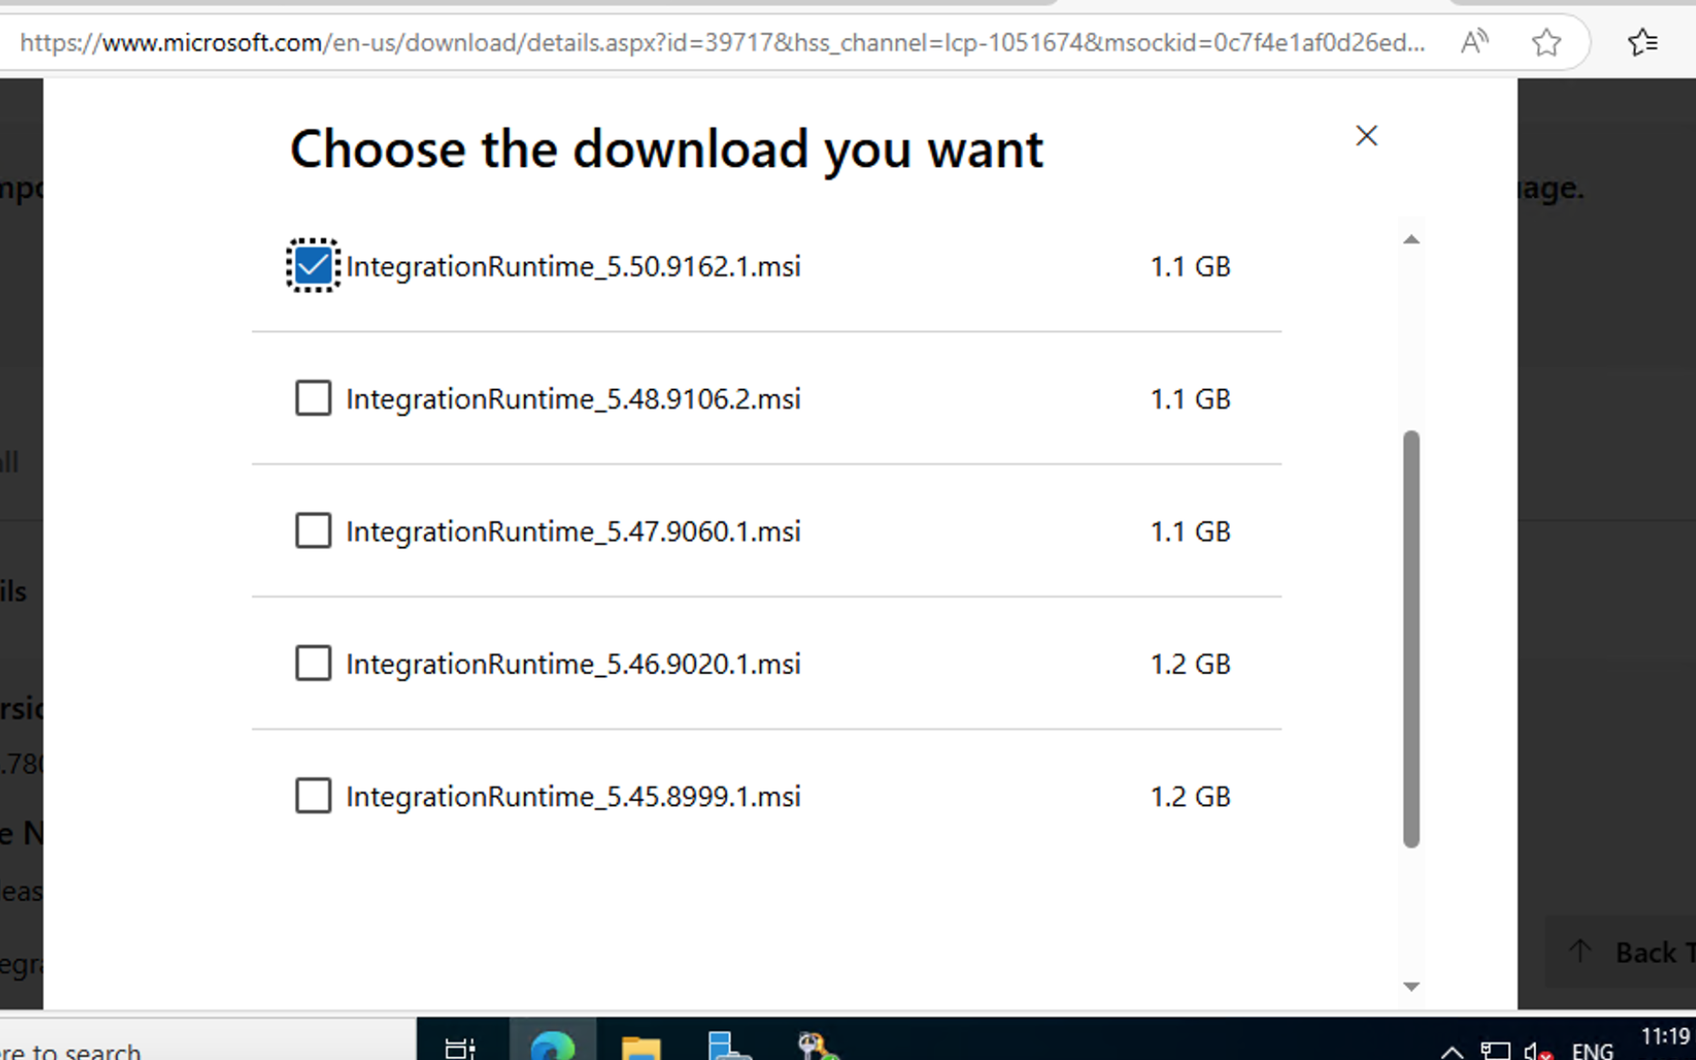 After this Go to Synapse to create Self hosted integration run time. Synapse->Manage->Integration runtime->Create-> Selfhosted-> Give details-> Create->Copy the key

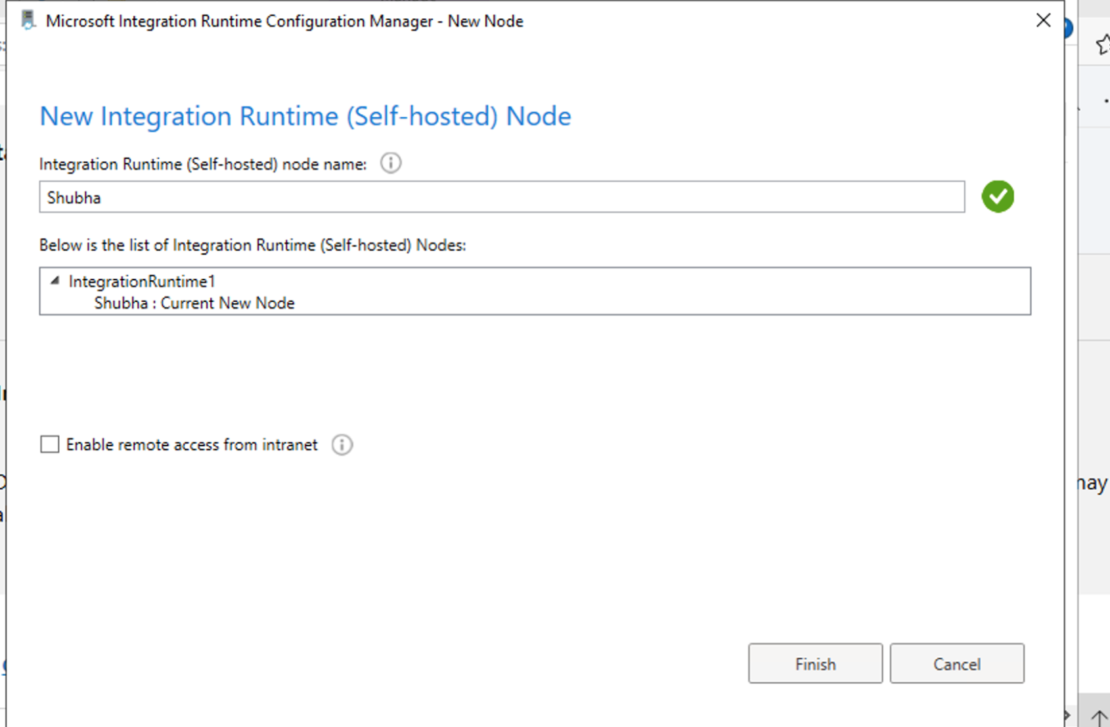 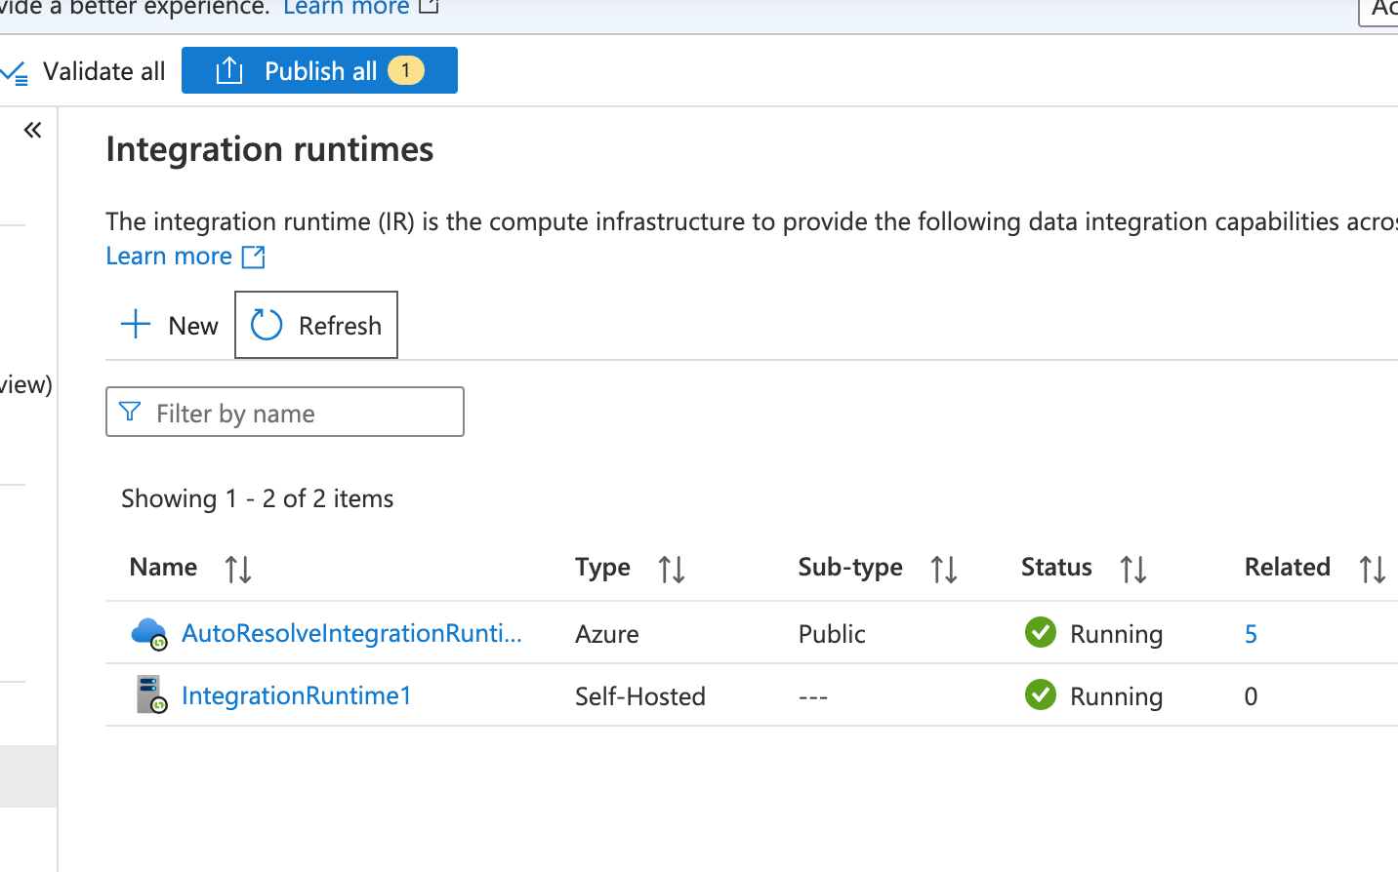Open Microsoft SQL Server Management and give the same details which u given in VM creation , encryption --- option

Now first create a Database called Onpremsqldb

Create database onpremsqldb

**Data Loading with Incremental Processing**

**1. Table Creation:**

**Create 5 tables, where:**

**Two tables should have a column with int data type that serves as a unique identifier.**  
CREATE TABLE PEOPLE (

ID INT,

PERSON_NAME VARCHAR(50),

PERSON_CITY VARCHAR(20),

PERSON_SAL INT,

PERSON_PHNO BIGINT,

FAVORITE_COLOR VARCHAR(20) NULL -- Allows NULL values

);

INSERT INTO PEOPLE (ID, PERSON_NAME, PERSON_CITY, PERSON_SAL, PERSON_PHNO, FAVORITE_COLOR)

VALUES

(1, 'SHUBHA', 'NEWYORK', 20000, 58585855858, NULL),

(2, 'RAMA', 'DENMARK', 80000, 98585855858, NULL),

(3, 'SHAMITHA', 'BALI', 70000, 18585855858, NULL),

(4, 'ALICE', 'LONDON', 65000, 75858585858, 'Green'),

(5, 'BOB', 'TORONTO', 72000, 65858585858, 'Yellow'),

(6, 'CHARLIE', 'SYDNEY', 80000, 55858585858, 'Orange');

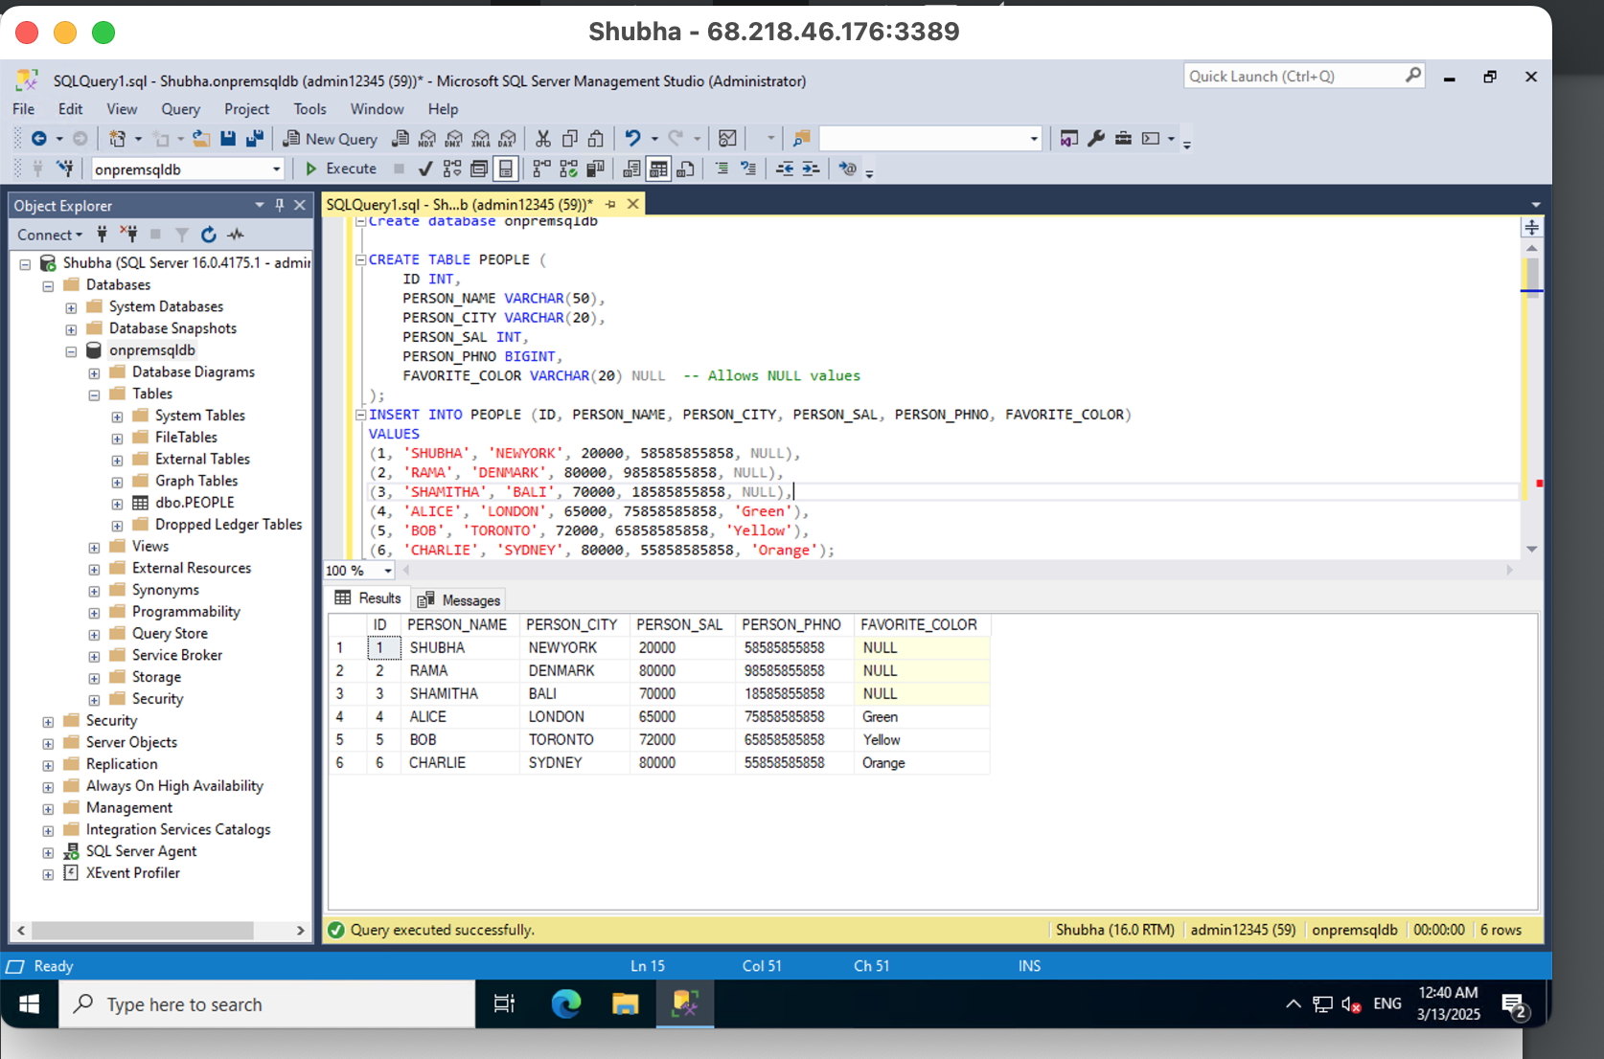 CREATE TABLE EMPLOYEE

(

EMP_ID INT, EMP_NAME VARCHAR(50), EMP_CITY VARCHAR(20),

EMP_SAL INT,EMP_PHNO BIGINT

)

INSERT INTO EMPLOYEE VALUES ( 1, 'SHUBHA', 'NEWYORK', 20000, 58585855858)

INSERT INTO EMPLOYEE VALUES ( 2, 'RAMA', 'DENMARK', 80000, 98585855858)

INSERT INTO EMPLOYEE VALUES ( 3, 'SHAMITHA', 'BALI', 70000, 18585855858) 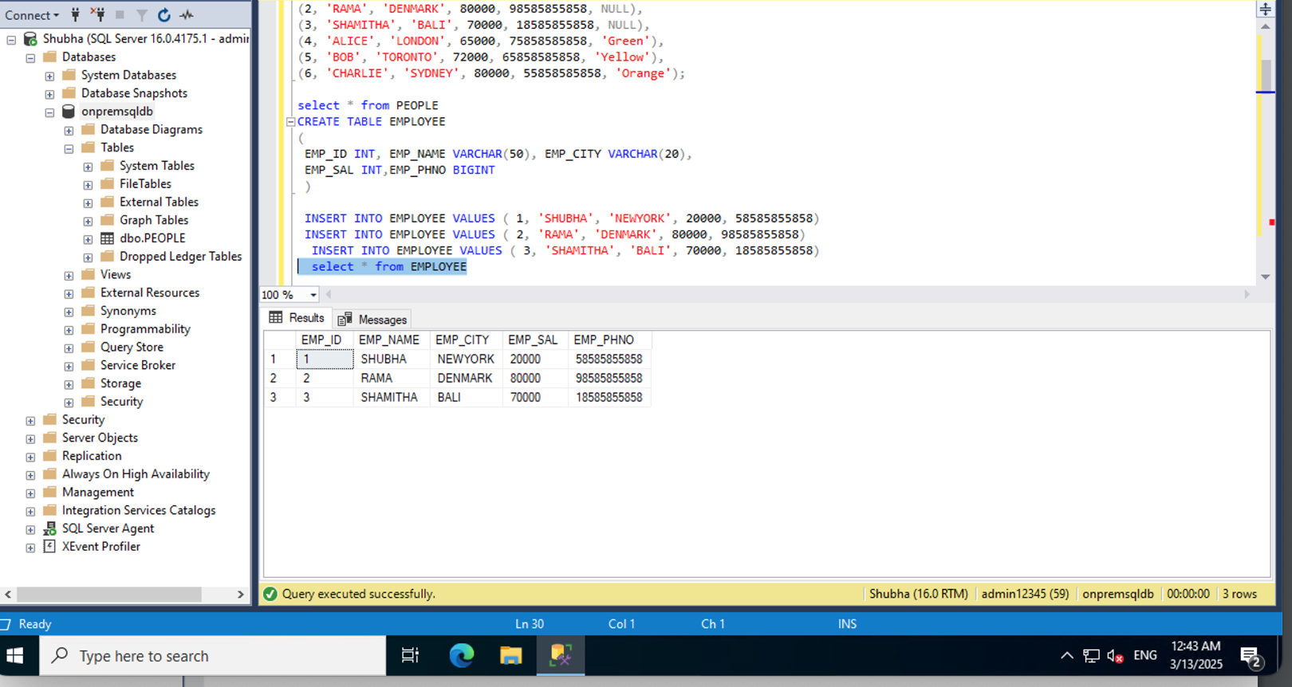 **Three tables should have a datetime column to track the time of data insertion or update.**

CREATE table CUST(

CID INT, CNAME VARCHAR(100), CCITY VARCHAR(100), UPDATED_DATE DATETIME)

INSERT INTO CUST (CID, CNAME, CCITY, UPDATED_DATE)

VALUES (1, 'John Doe', 'New York', '2025-03-01 10:30:00');

INSERT INTO CUST (CID, CNAME, CCITY, UPDATED_DATE)

VALUES (2, 'Jane Smith', 'Los Angeles', '2025-03-01 11:00:00');

INSERT INTO CUST (CID, CNAME, CCITY, UPDATED_DATE)

VALUES (3, 'Robert Brown', 'Chicago', '2025-03-01 12:00:00');

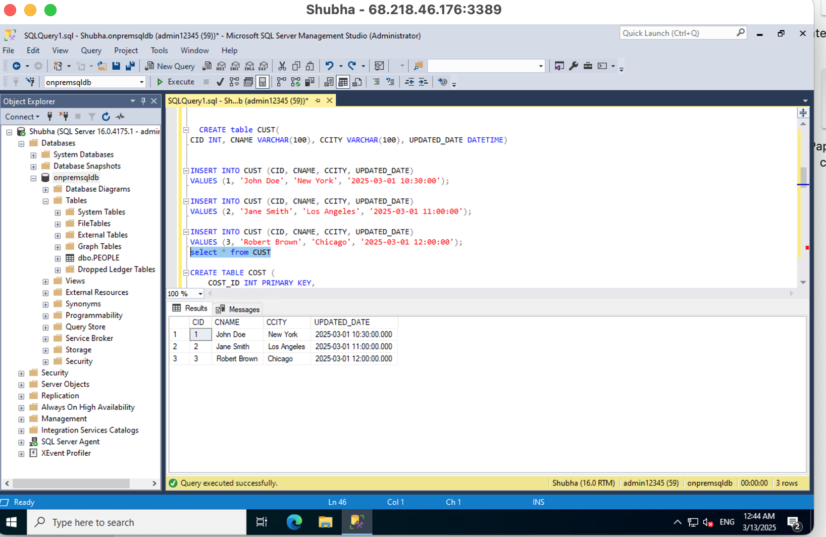 CREATE TABLE COST (

COST_ID INT PRIMARY KEY,

COST_NAME VARCHAR(100) NOT NULL,

COST_AMOUNT DECIMAL(10,2),

UPDATED_DATE DATETIME

);

INSERT INTO COST (COST_ID, COST_NAME, COST_AMOUNT, UPDATED_DATE)

VALUES (1, 'Labor Cost', 5000.00, '2025-03-01 10:00:00');

INSERT INTO COST (COST_ID, COST_NAME, COST_AMOUNT, UPDATED_DATE)

VALUES (2, 'Material Cost', 12000.50, '2025-03-01 11:00:00');

INSERT INTO COST (COST_ID, COST_NAME, COST_AMOUNT, UPDATED_DATE)

VALUES (3, 'Transportation Cost', 3000.75, '2025-03-01 12:00:00');

SELECT * FROM COST; 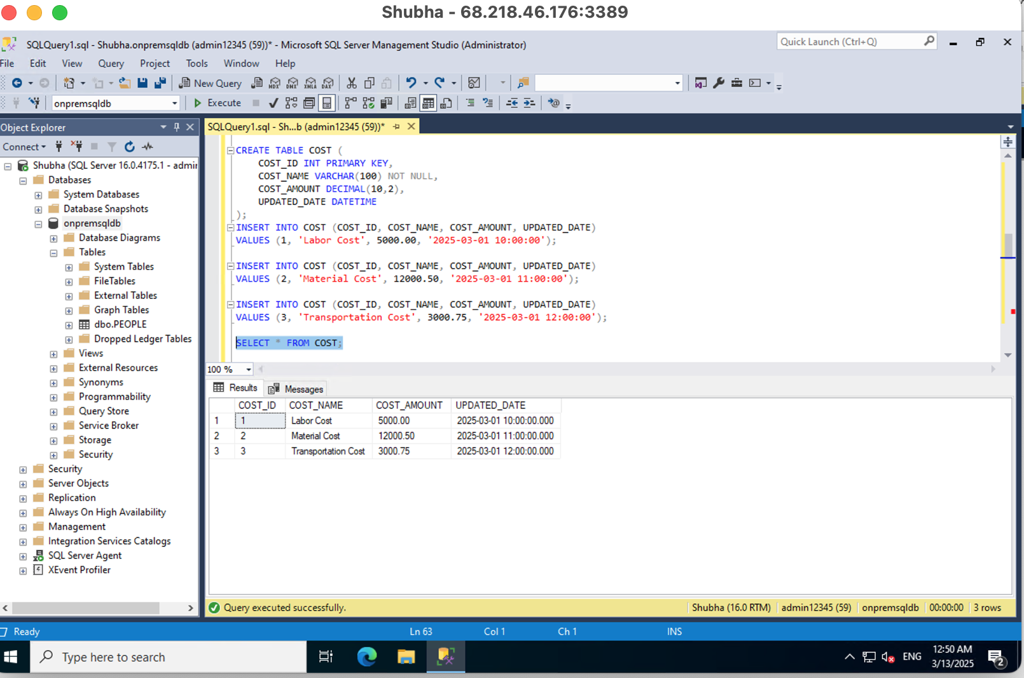 CREATE TABLE ORDERS (

ORDER_ID INT,

CUSTOMER_ID INT,

ORDER_AMOUNT DECIMAL(10,2),

ORDER_DATE DATETIME

);

INSERT INTO ORDERS (ORDER_ID, CUSTOMER_ID, ORDER_AMOUNT, ORDER_DATE)

VALUES (1, 1, 150.00, '2025-03-01 14:00:00');

INSERT INTO ORDERS (ORDER_ID, CUSTOMER_ID, ORDER_AMOUNT, ORDER_DATE)

VALUES (2, 2, 250.75, '2025-03-01 15:00:00');

INSERT INTO ORDERS (ORDER_ID, CUSTOMER_ID, ORDER_AMOUNT, ORDER_DATE)

VALUES (3, 3, 99.99, '2025-03-01 16:00:00');

SELECT * FROM ORDERS; 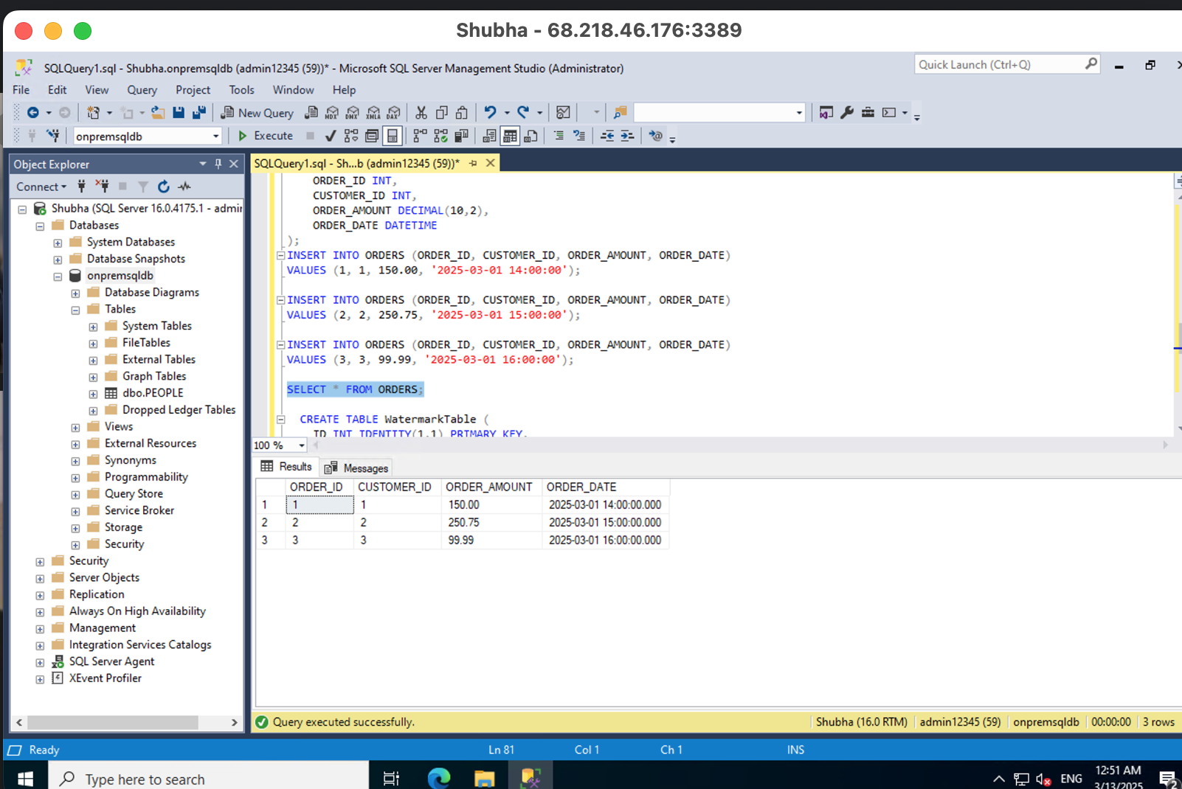2. Watermark Table:

• Create a watermark table that will store the last processed value (int or datetime) for each table. This will be used to track the most recent value processed, ensuring that only new data is loaded during subsequent runs.

CREATE TABLE WatermarkTable (

ID INT IDENTITY(1,1) PRIMARY KEY,

schema_name VARCHAR(50),

Table_name VARCHAR(50),

LPV VARCHAR(100),

Delta_col VARCHAR(50)

);

Insert into WatermarkTable values ('dbo', 'PEOPLE' , '0', 'ID')

Insert into WatermarkTable values ('dbo', ‘EMPLO’YEE , '0', ‘EMP_ID')

Insert into WatermarkTable values ('dbo', 'CUST' , '2025-03-01 10:00:00', ‘UPDATED_DATE)

Insert into WatermarkTable values ('dbo', 'COST' , '2025-03-01 10:00:00', 'UPDATED_DATE')

Insert into WatermarkTable values ('dbo', 'ORDERS' , '2025-03-01 14:00:00', 'ORDER_DATE')  
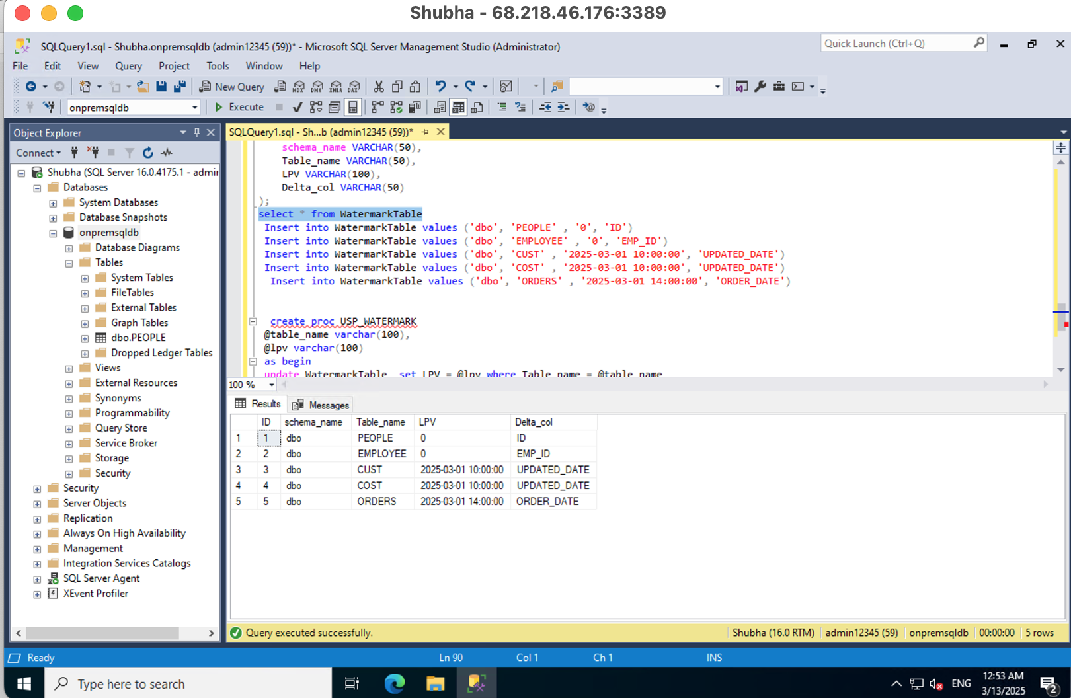**3. Stored Procedure for Incremental Data Load:**

• Write a stored procedure that:

• Takes the table name and the last processed value (from the watermark table) as inputs.

• Fetches the new records based on the last processed value (delta or datetime).

• Updates the watermark table after successfully loading the new records.  
create proc USP_WATERMARK

@table_name varchar(100),

@lpv varchar(100)

as begin

update WatermarkTable set LPV = @lpv where Table_name = @table_name

end

Creating a pipeline to migrate data between on_premise SQL DB to Azure ADLS storage account

**1. Watermark Table (Lookup)**

**Purpose:** Maintains metadata for tracking the last processed value (LPV) of each table.

**Functionality:**

* A Lookup activity retrieves the last processed value (LPV) from this table.
* This value is used in subsequent steps to determine which new records need to be processed.

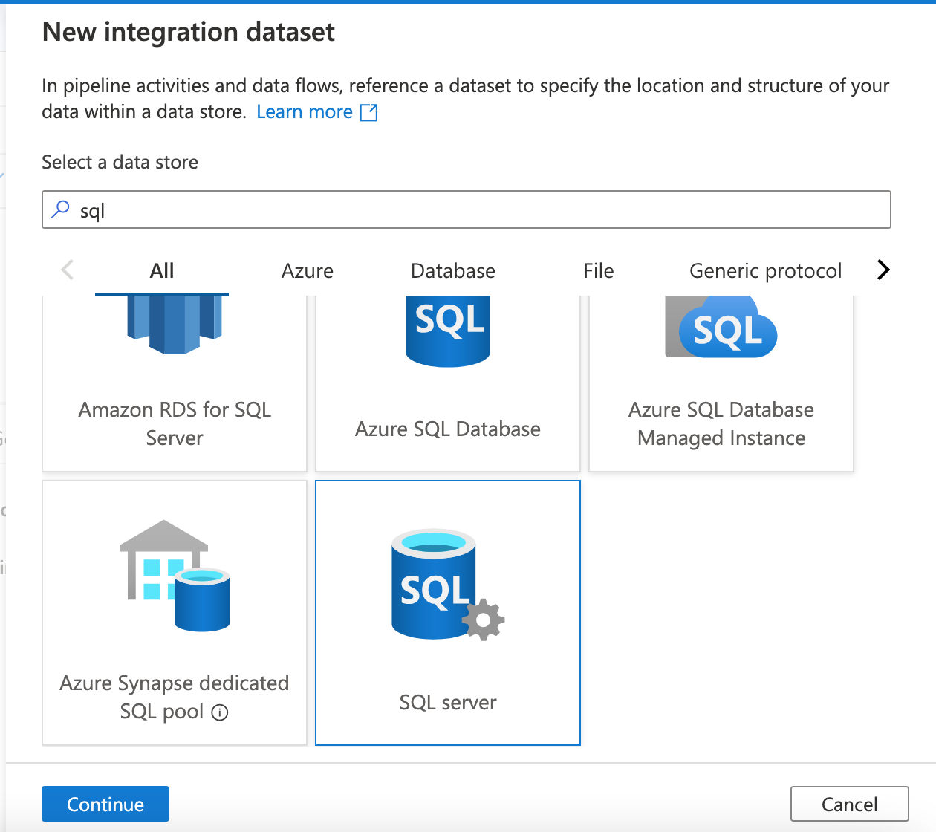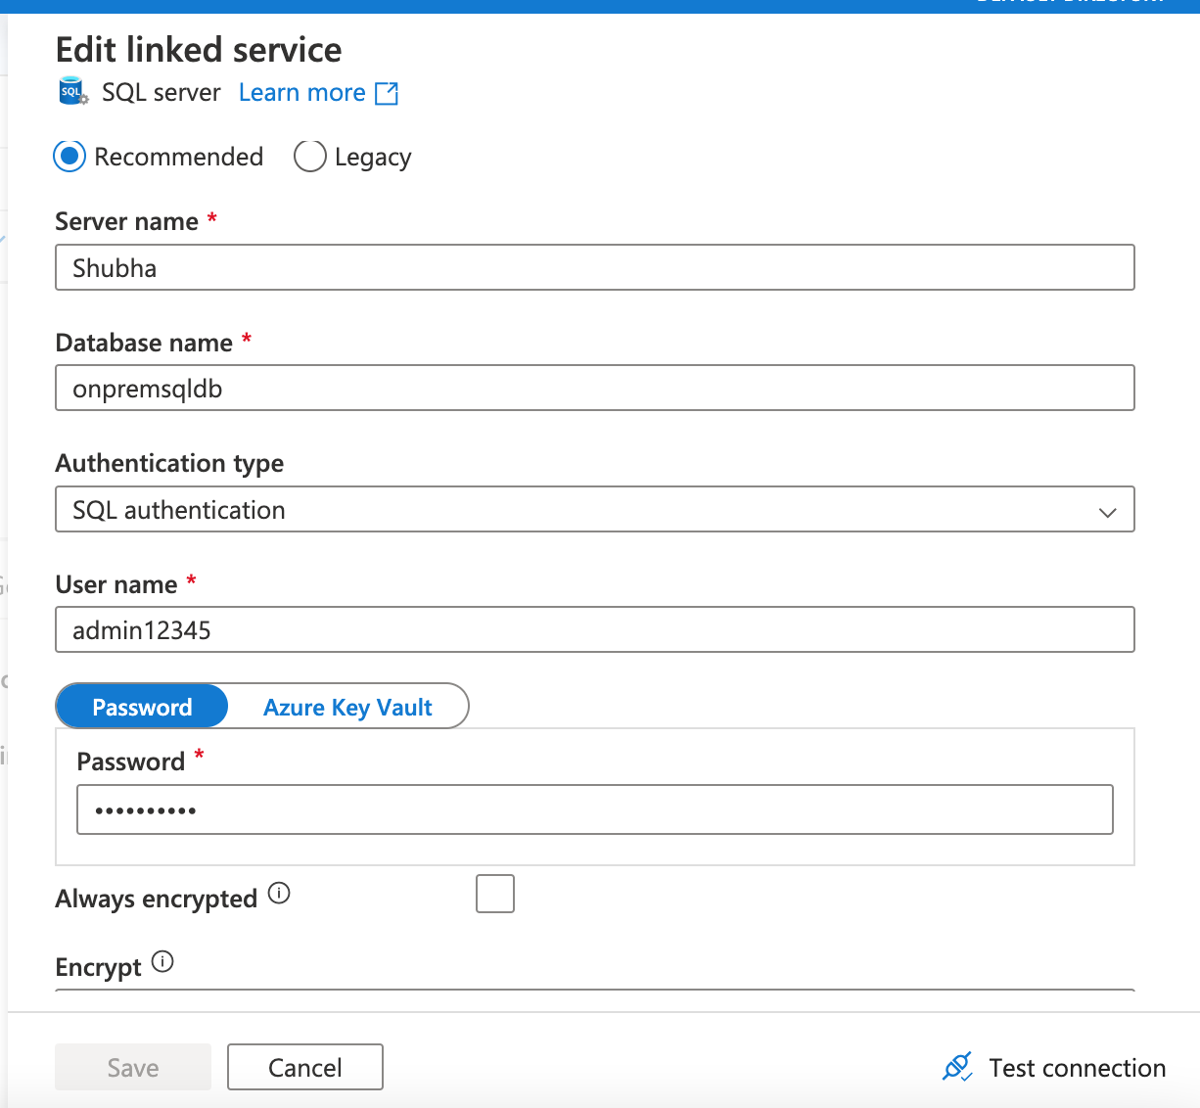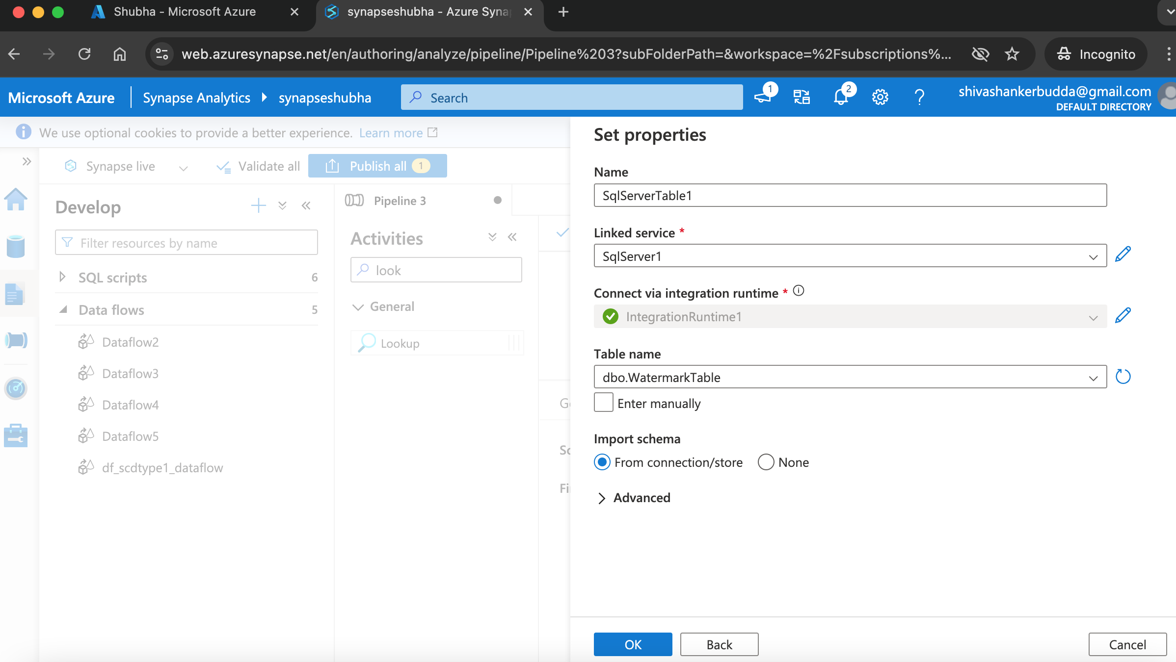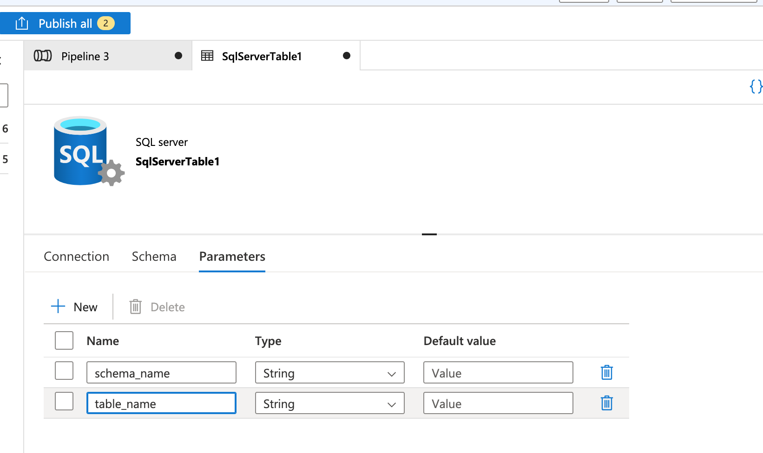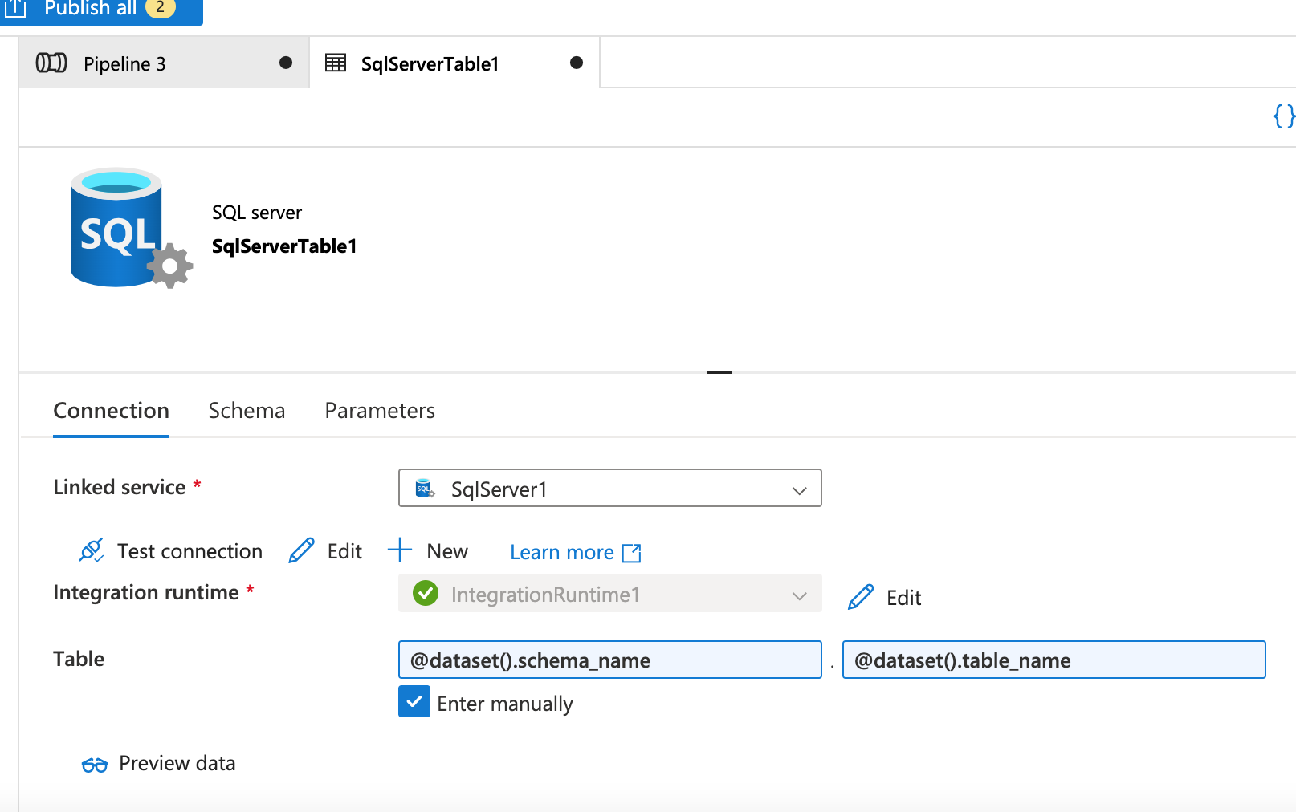 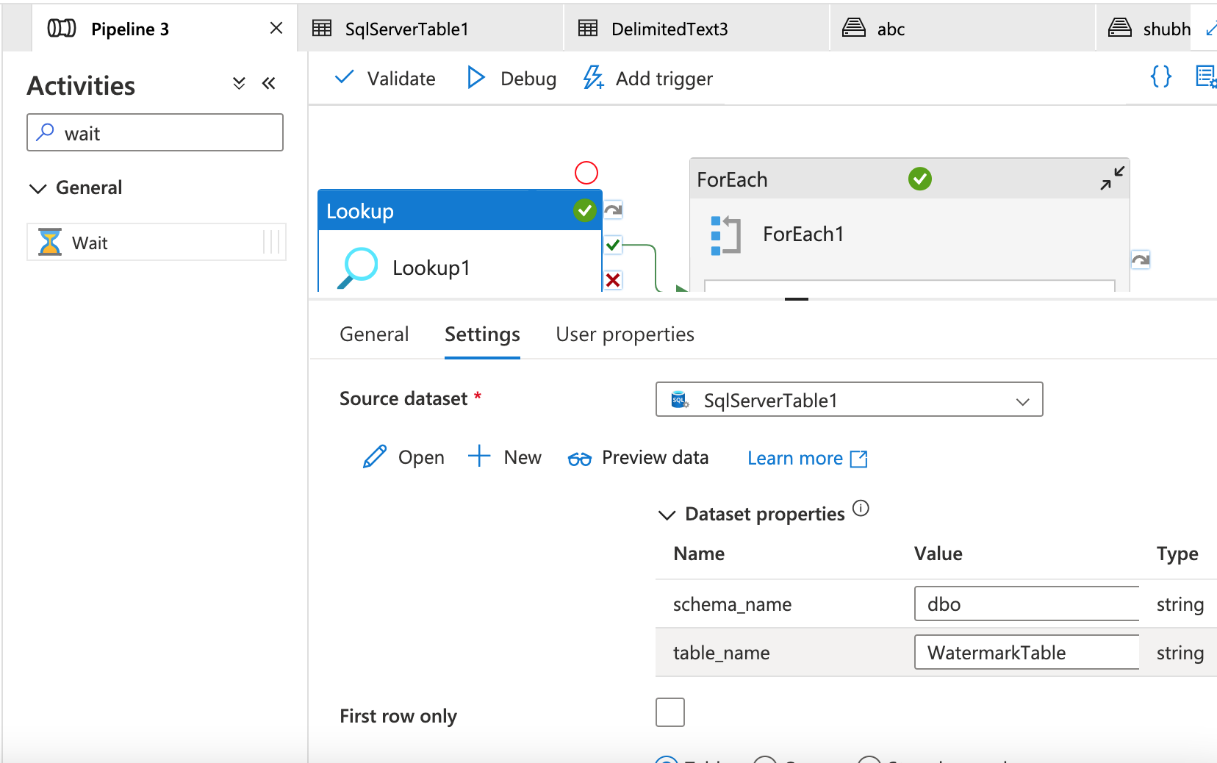 Drag on drop ForEach activity so it will loop through lookup, connect lookup to forEach on success. 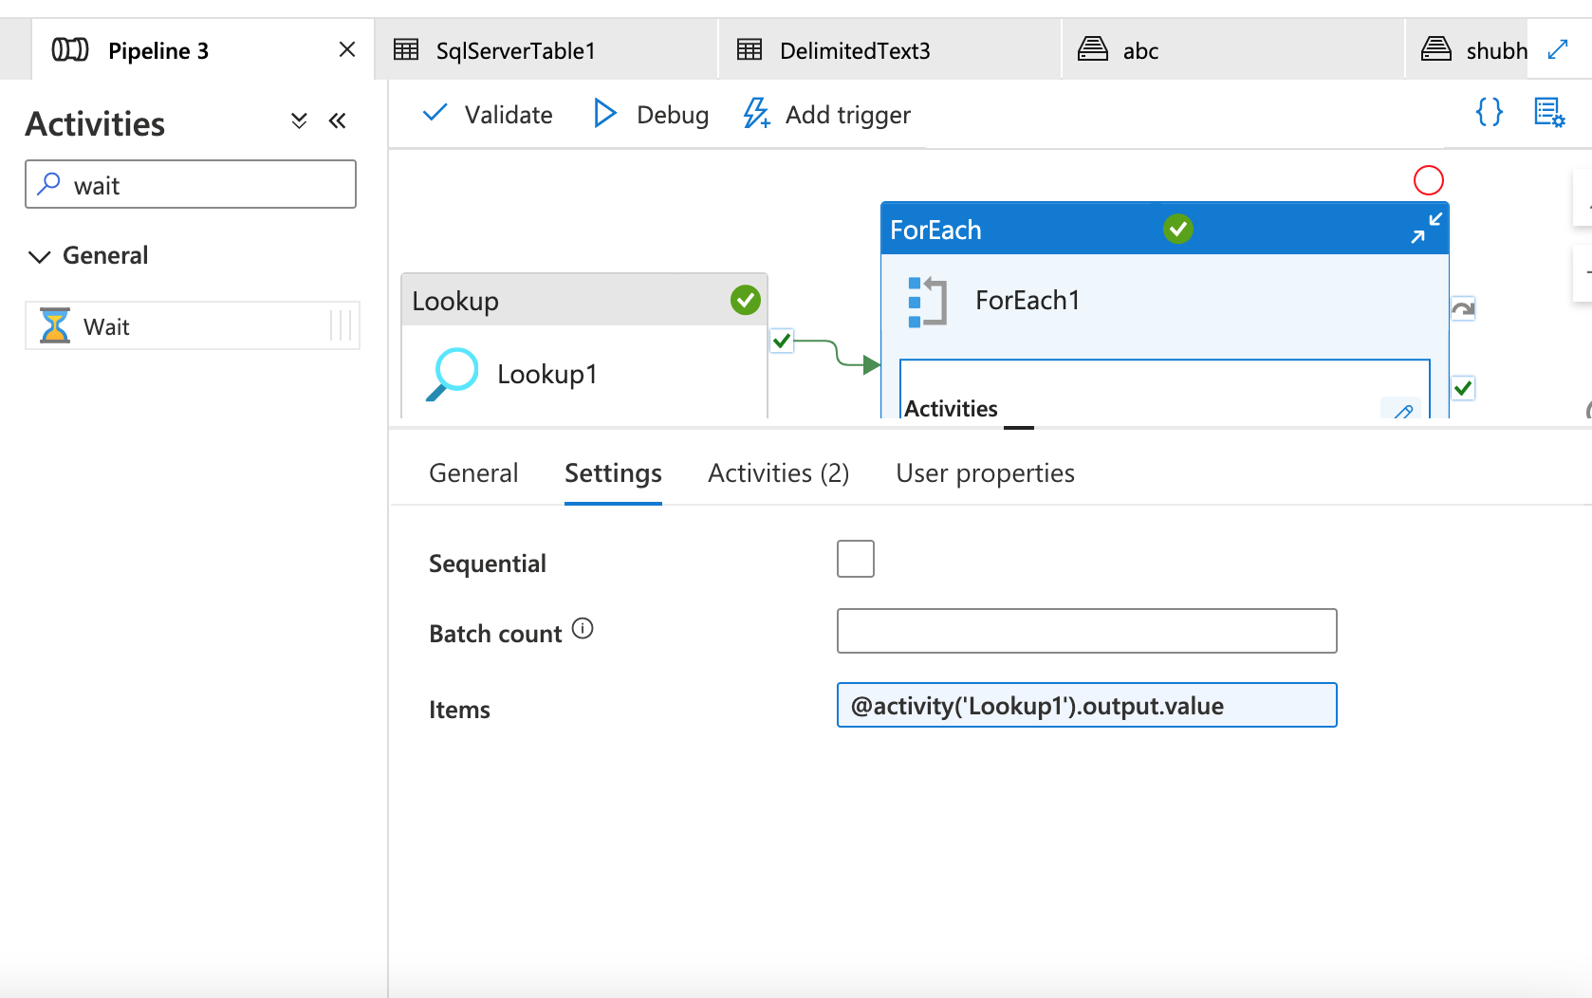 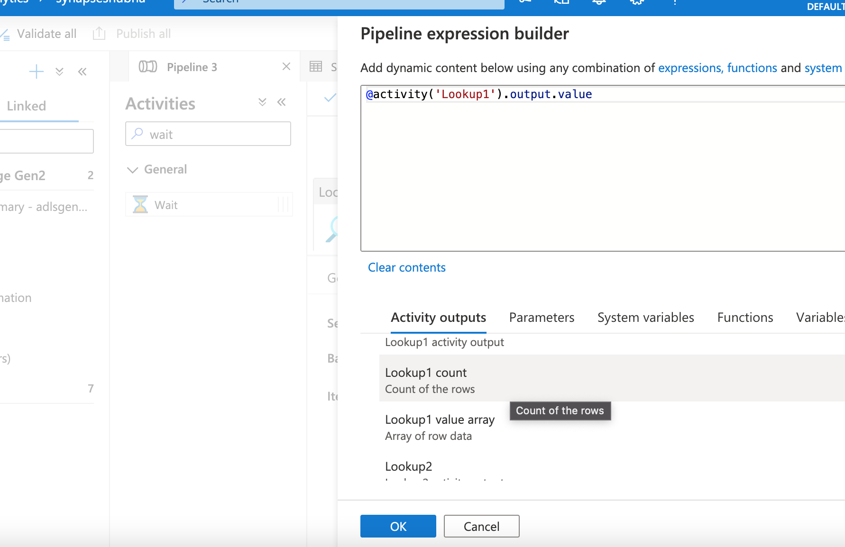 Inside forEach drag and drop another lookup activity which is used to find the max value for the given table, use the below query 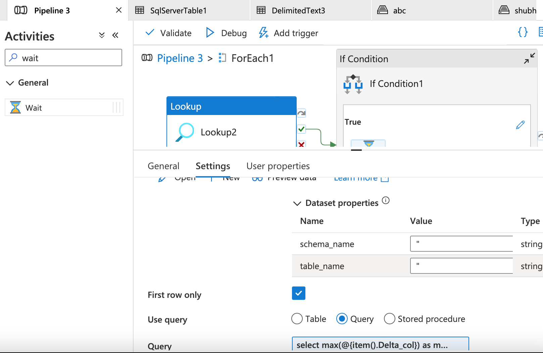

select max(@{item().Delta_Col}) as maxvalue from @{item().schema_Name}.@{item().Table_Name}

Then drag and drop if condition to avoid creating empty files when there is no new record or update in tables 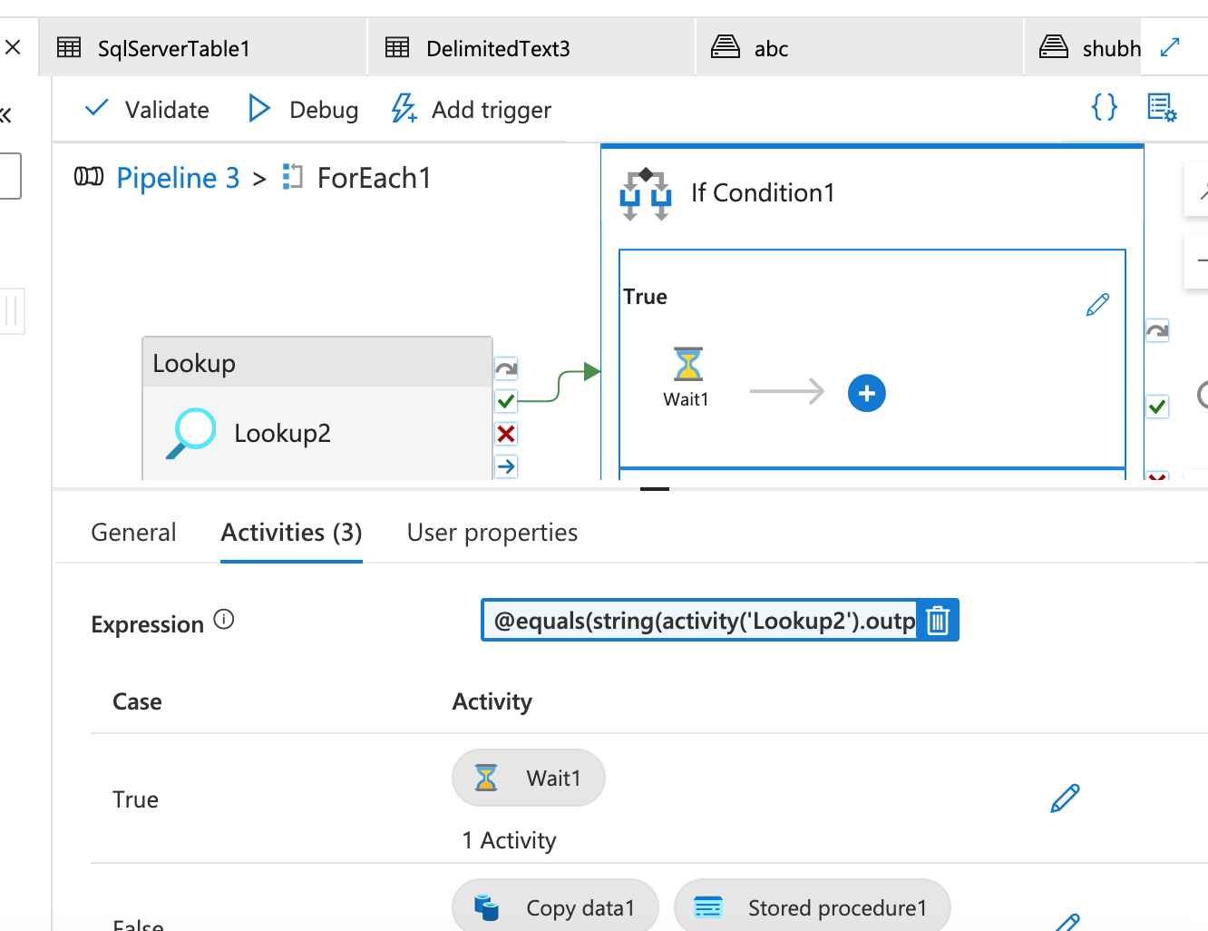 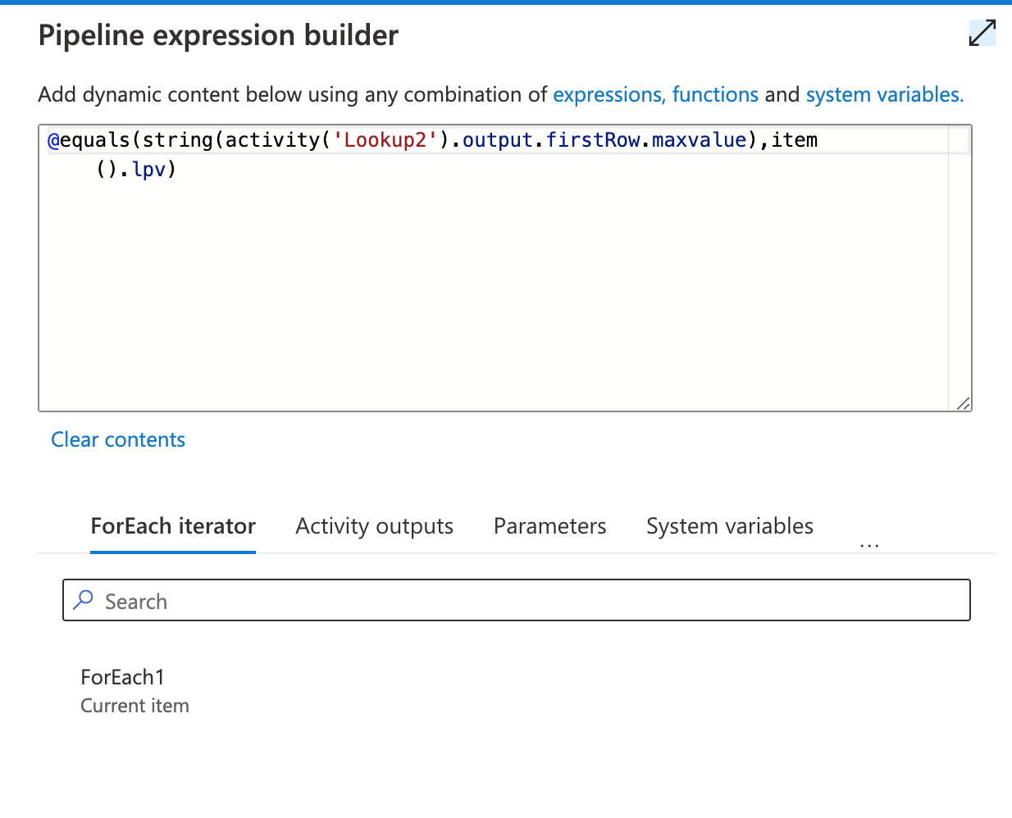 If max value and LPV value are same it will wait and

if it false it will perform copy activity, @equals(string(activity('LookupMax').output.firstRow.maxvalue),item().LPV)

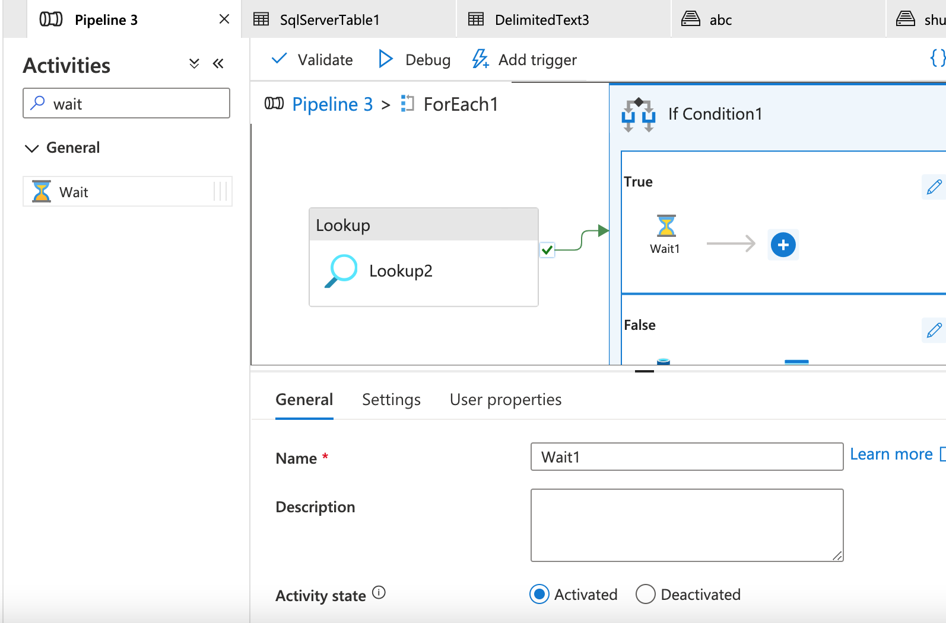 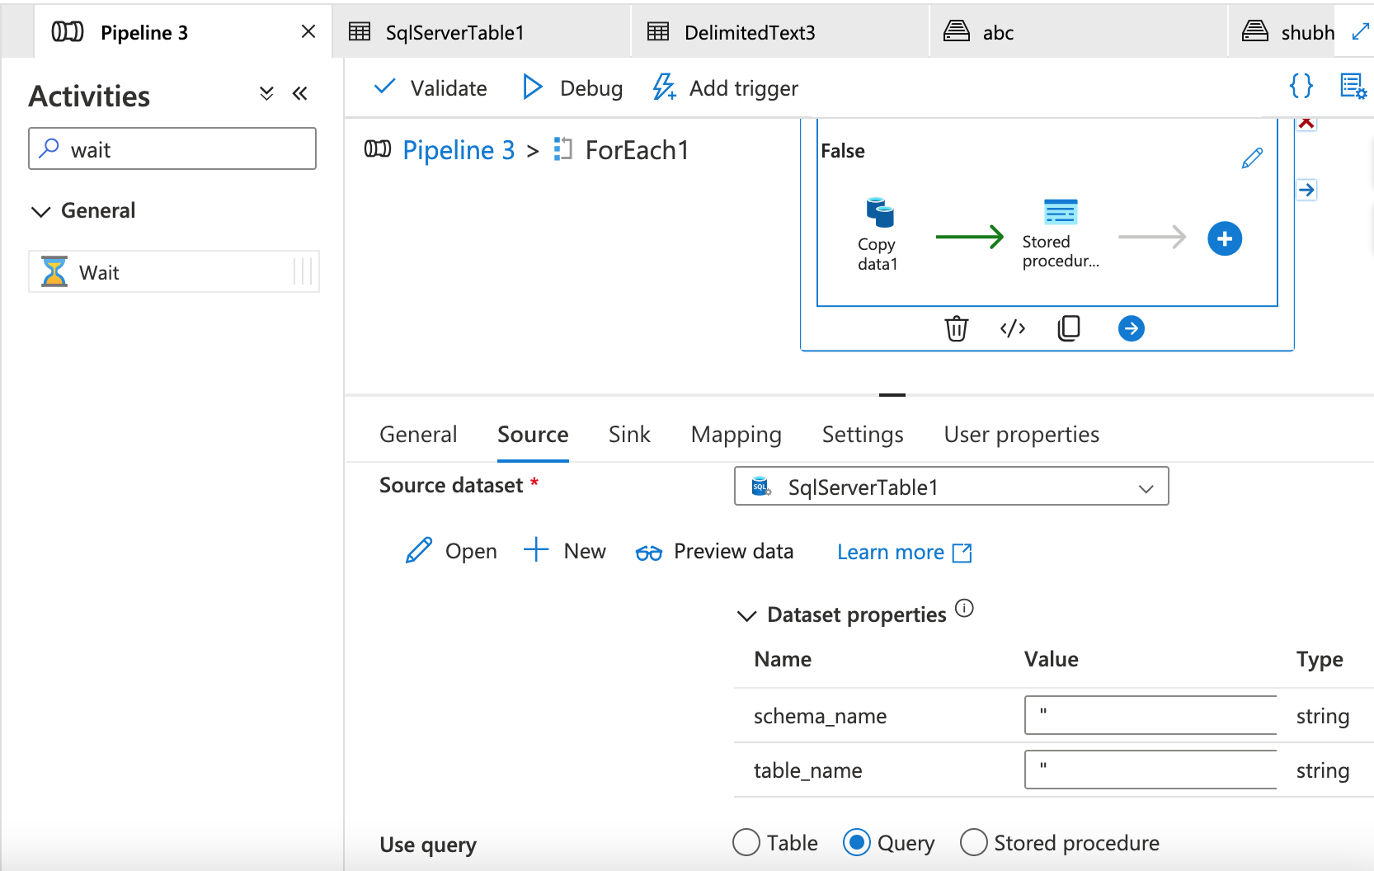

If True wait Drap and drop wait activity

Drag and drop copy activity first and here source is On-Premise SQL DB and we are bring data using query select * from @{item().Schema_name}.@{item().Table_Name} where @{item().Delta_Col}>@{item().LPV}

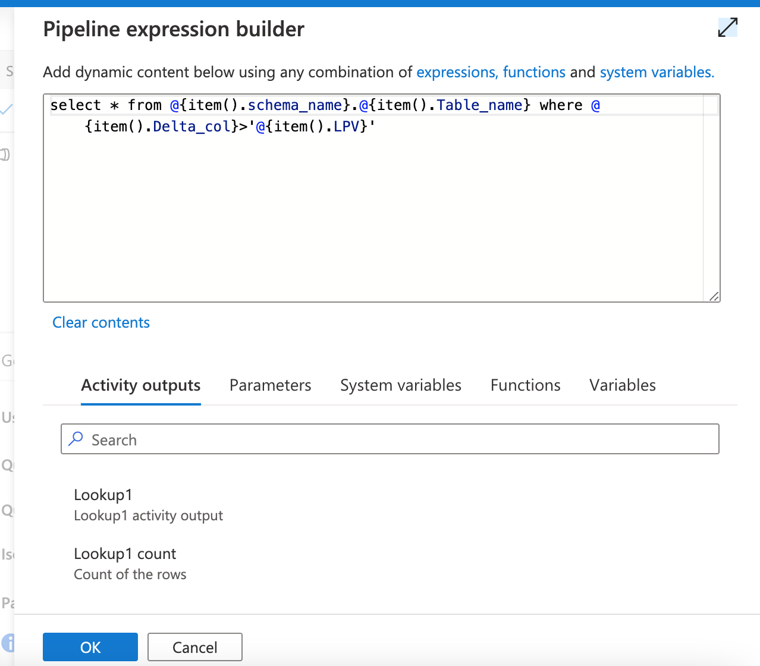 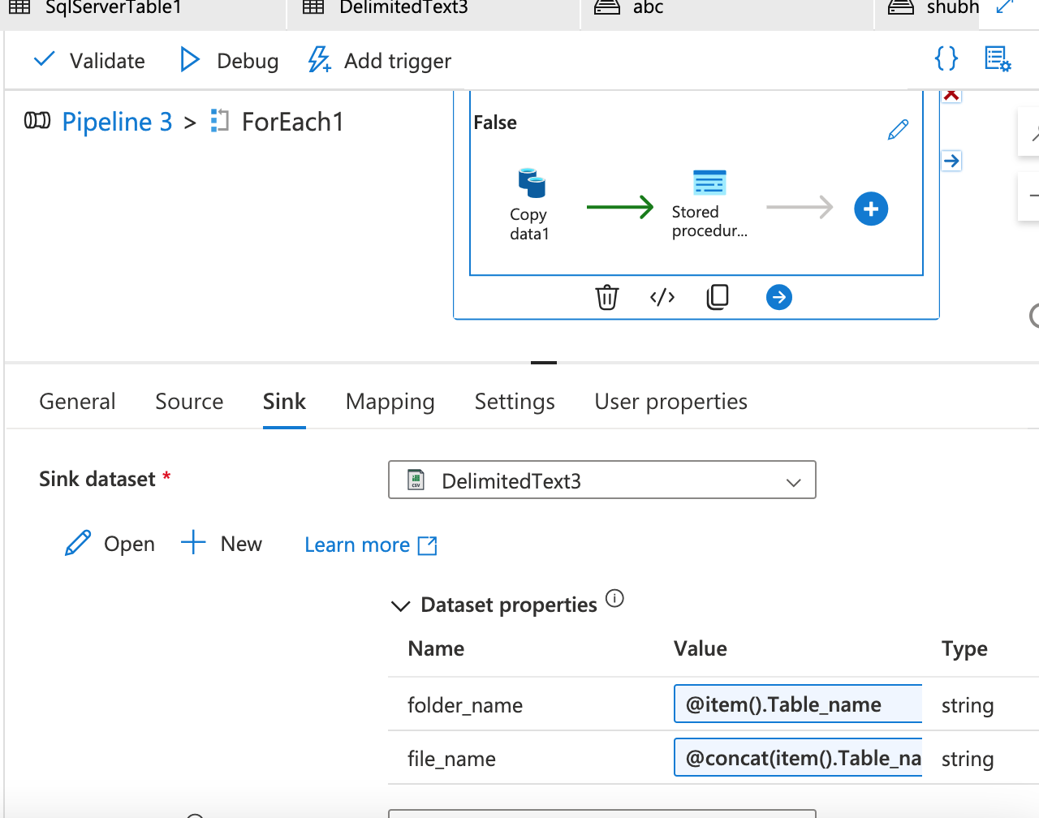 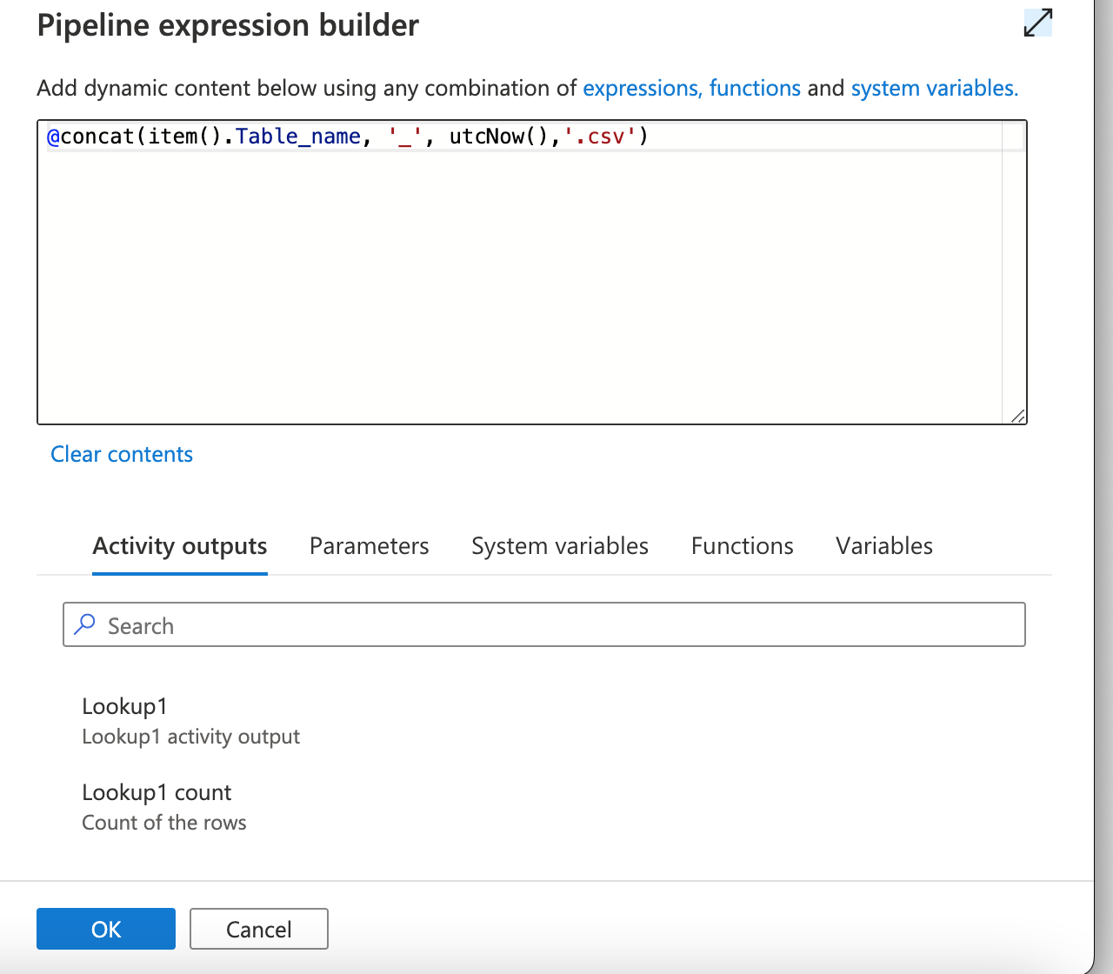 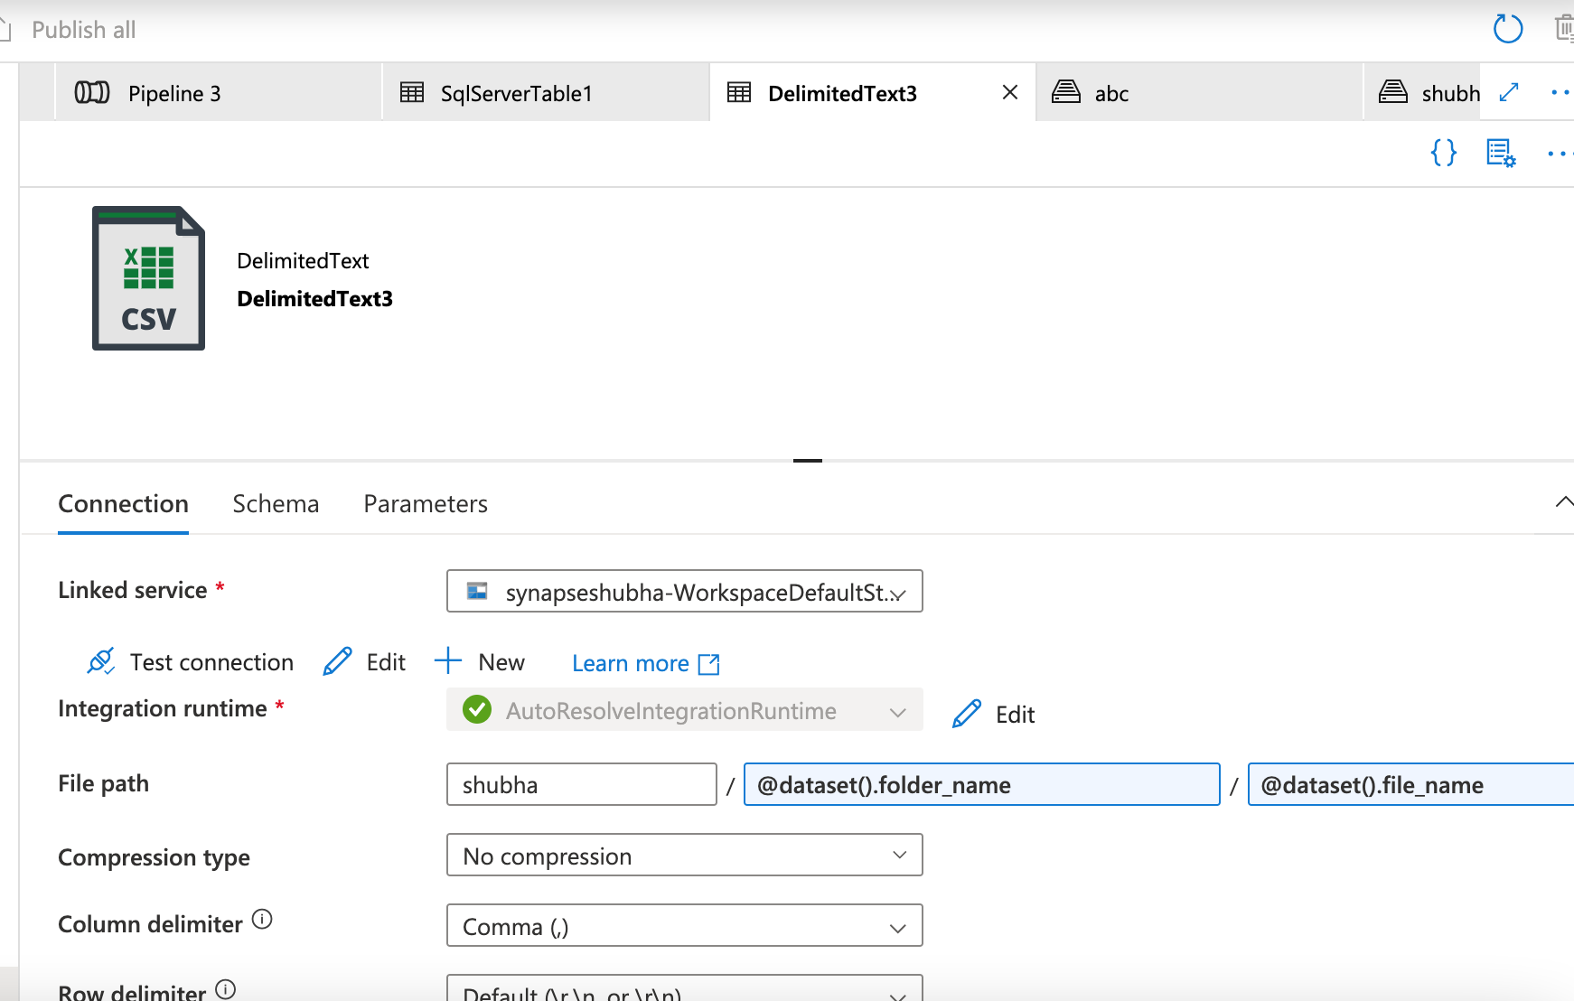 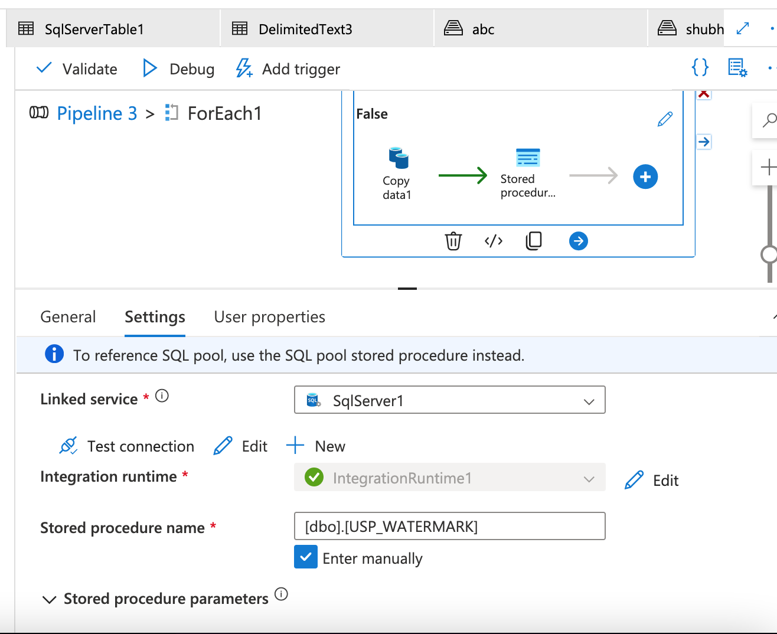 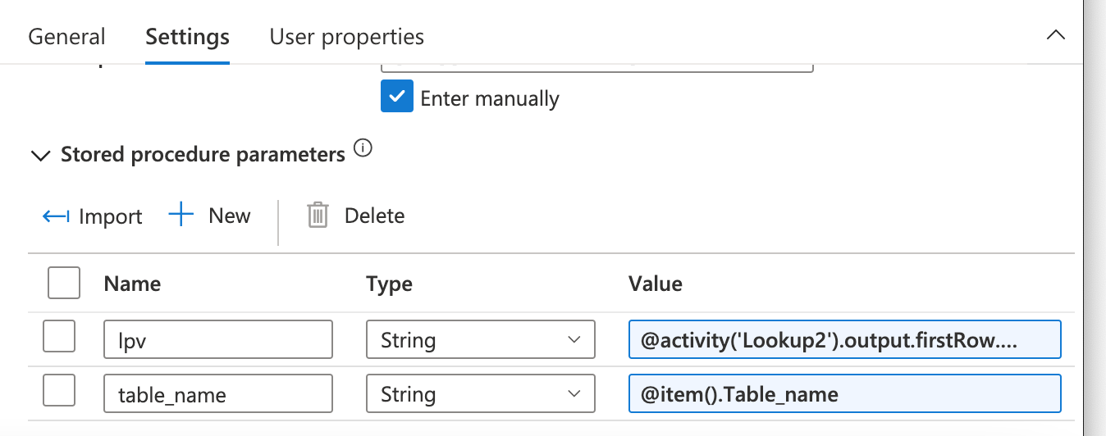 Publish and run the pipeline 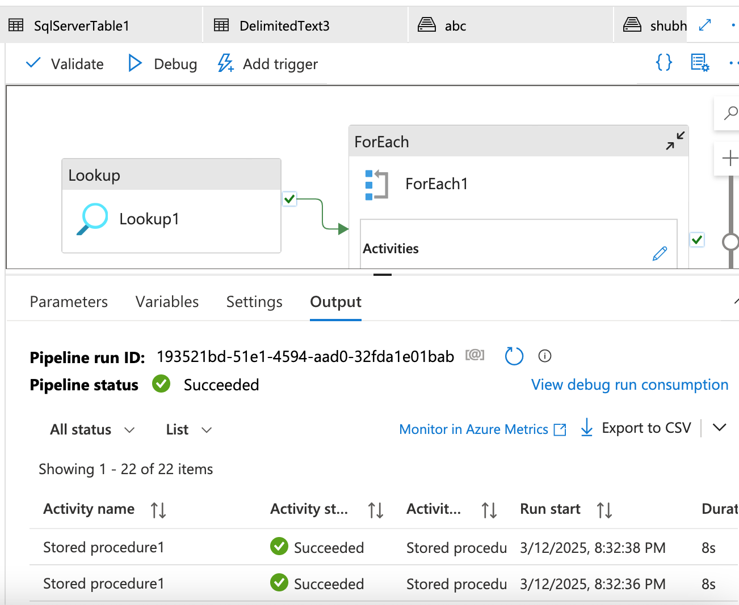 New folders were created in ADLS storage account 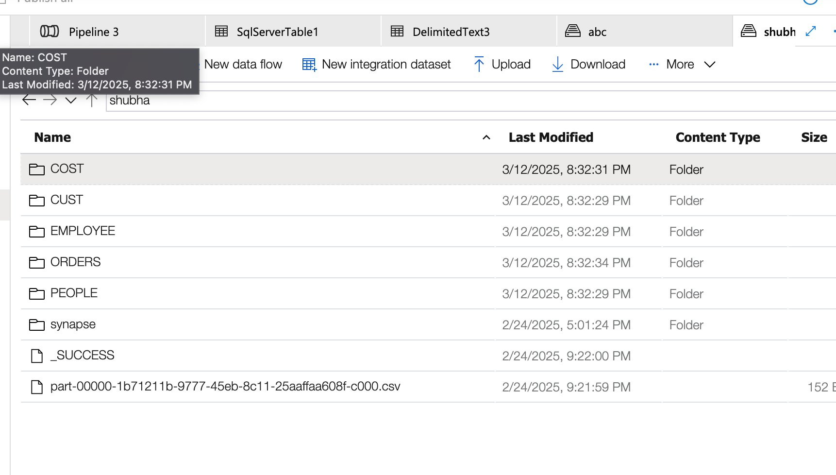 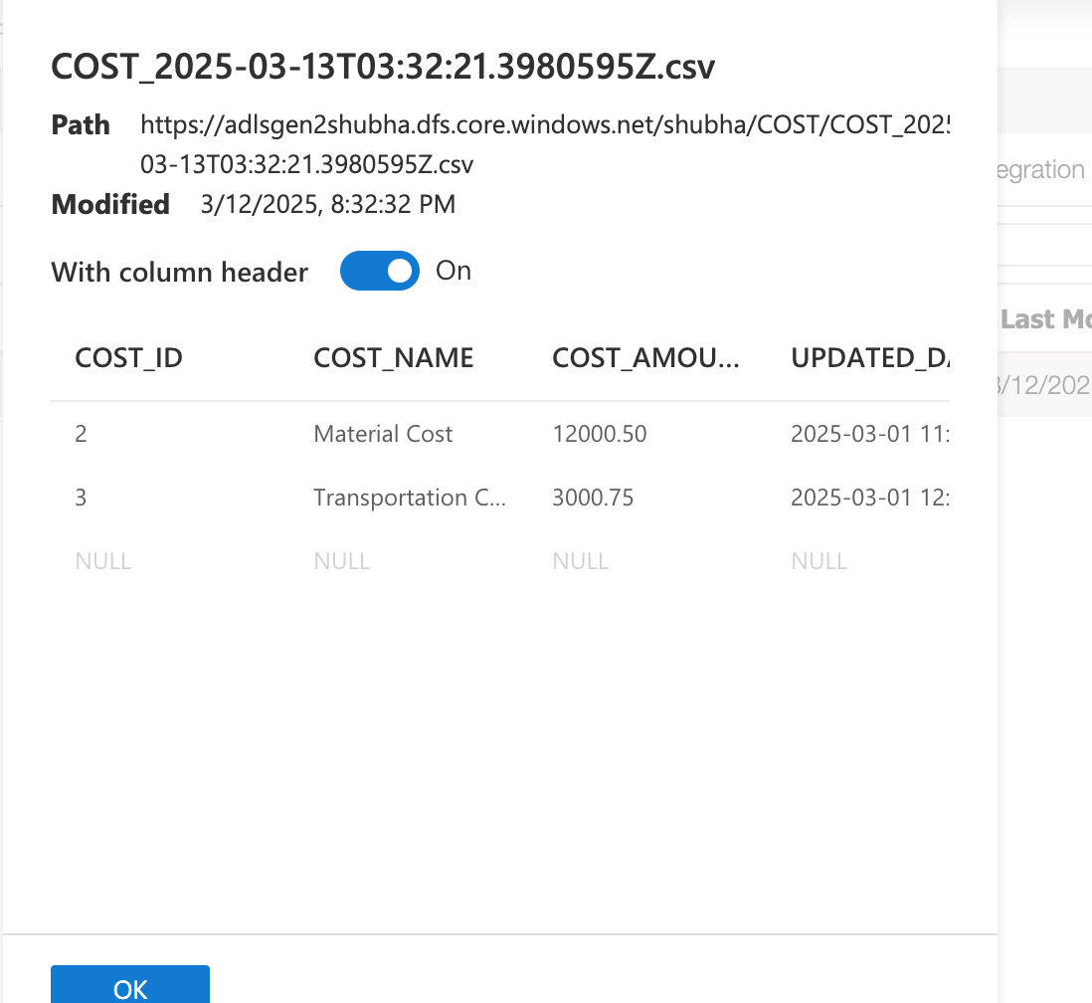 Creating SCD Type 1 and 2

SCD Type 1:

To build a pipeline for SCD type 1 first create a different folder in ADLS and copy a file which we copied using incremental load from on-premise DB.

Use the same Data we got from Watermark table

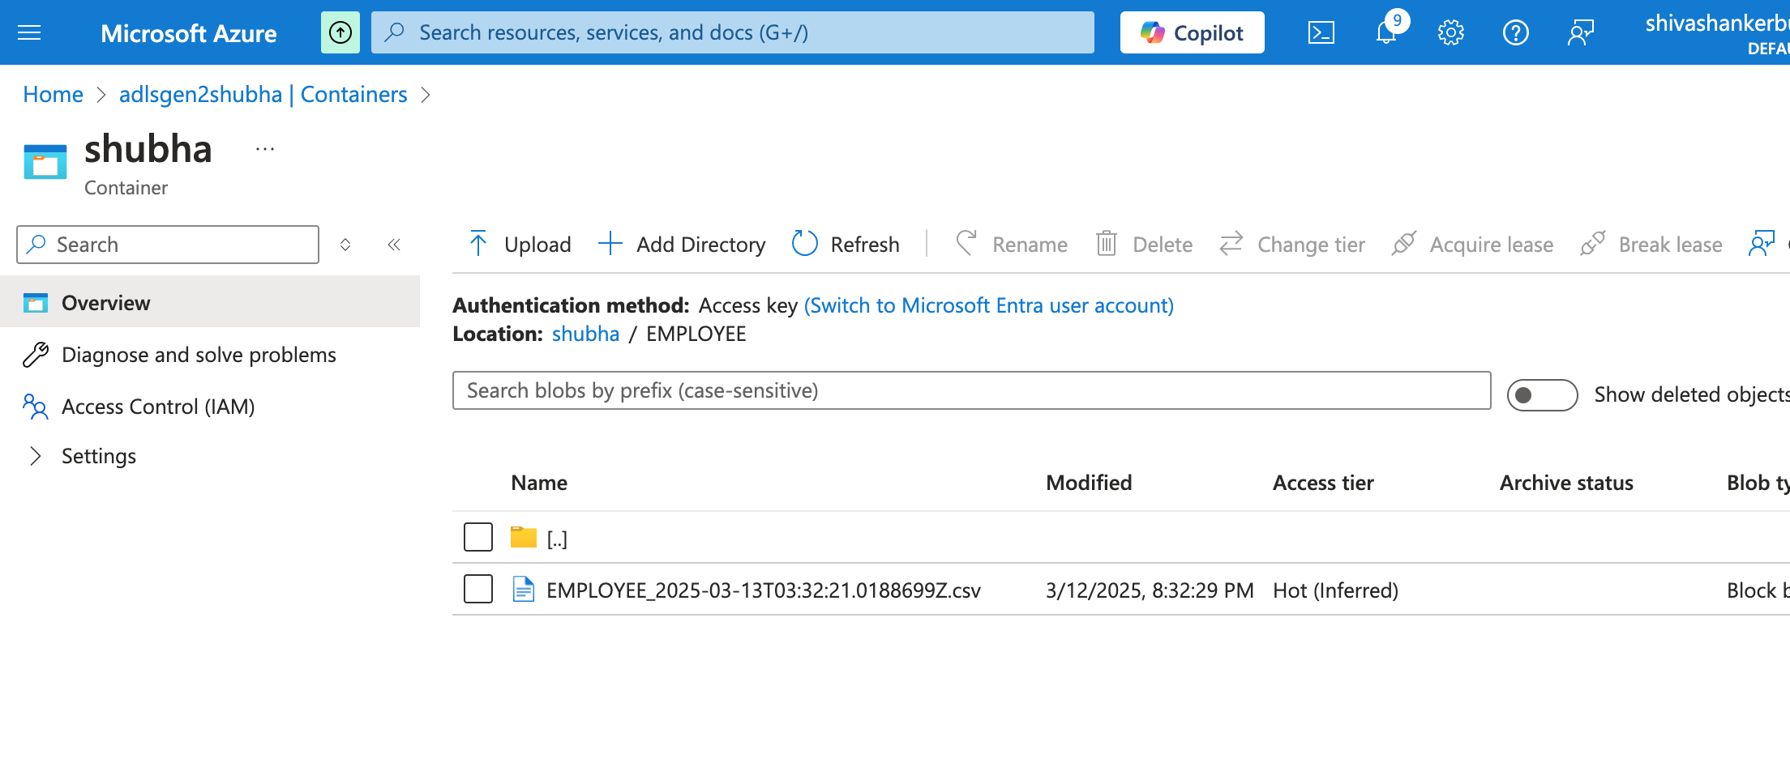 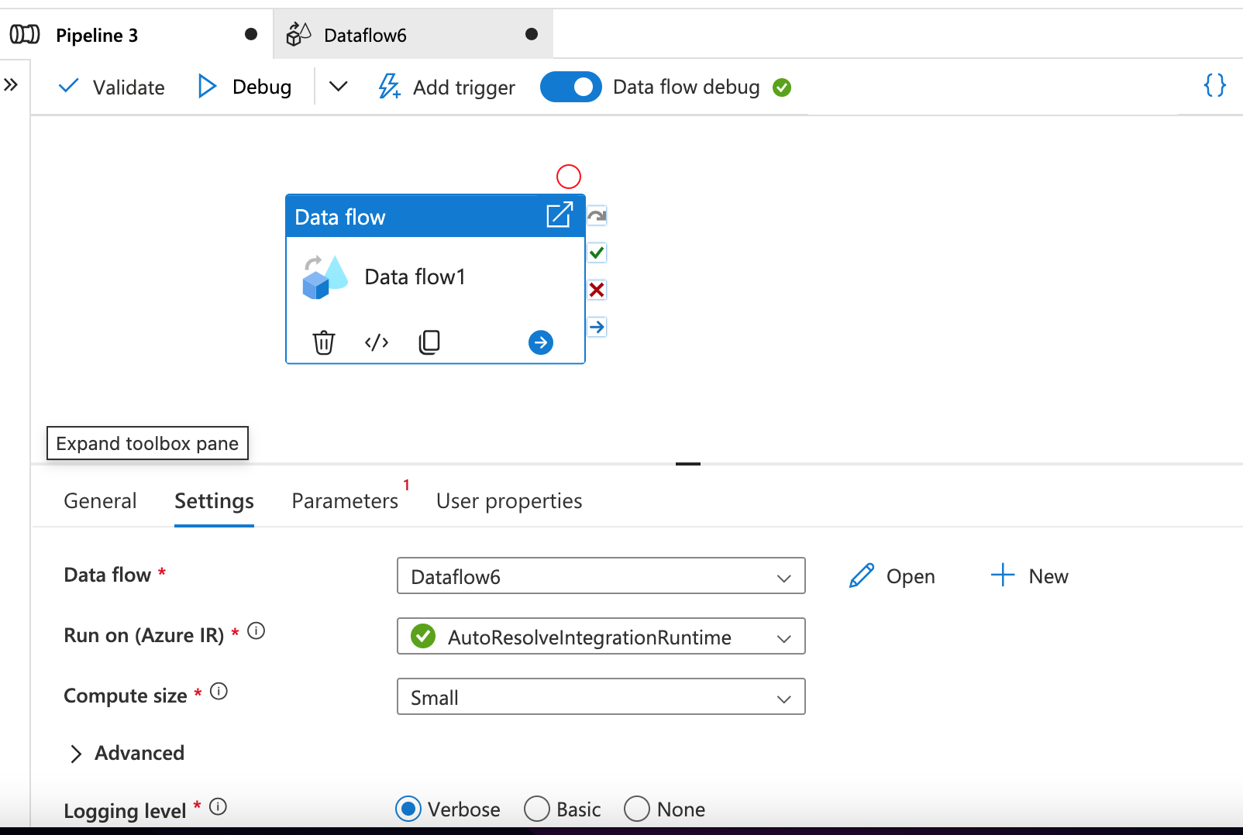 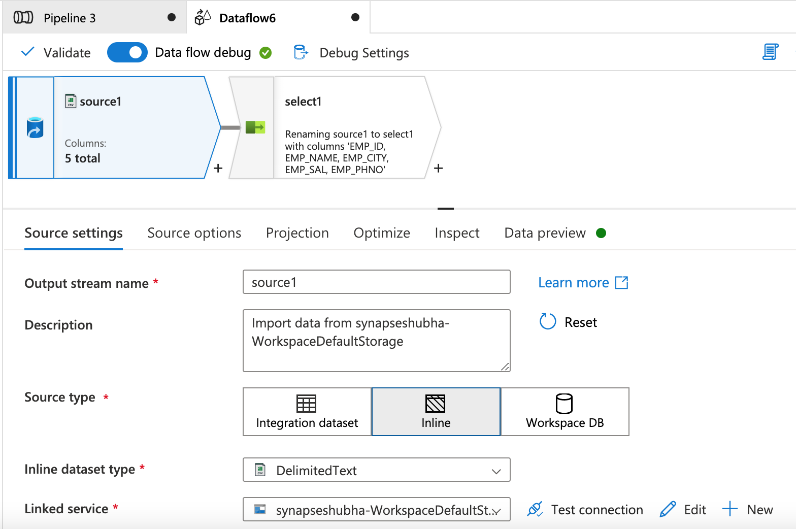 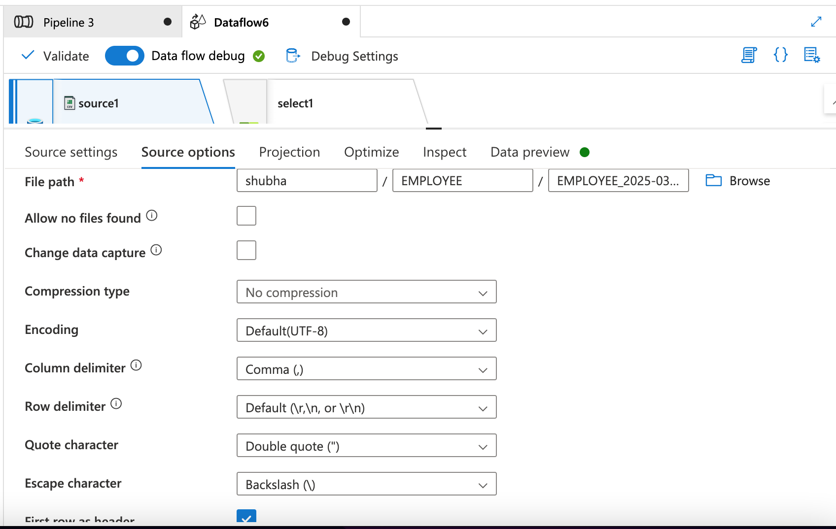 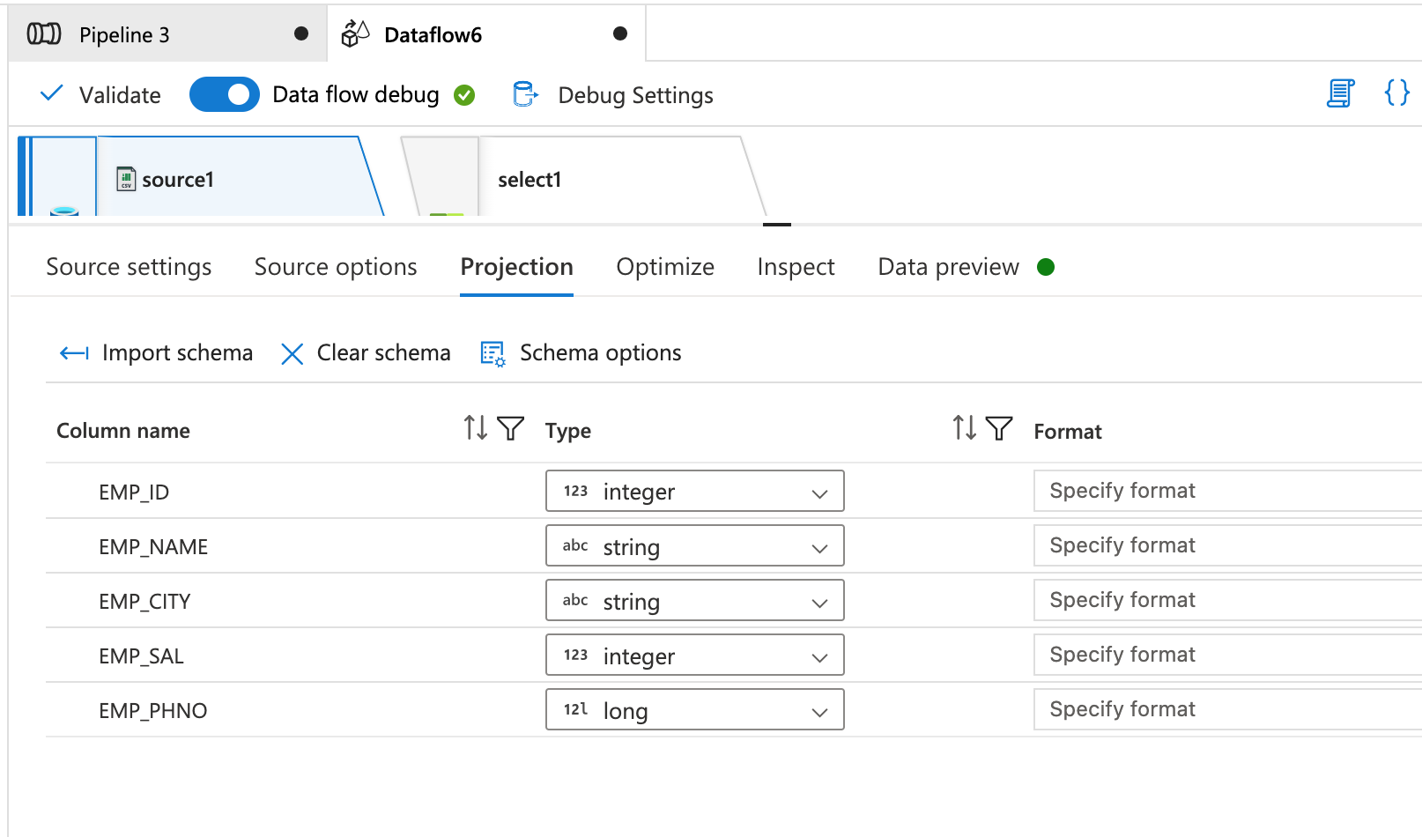 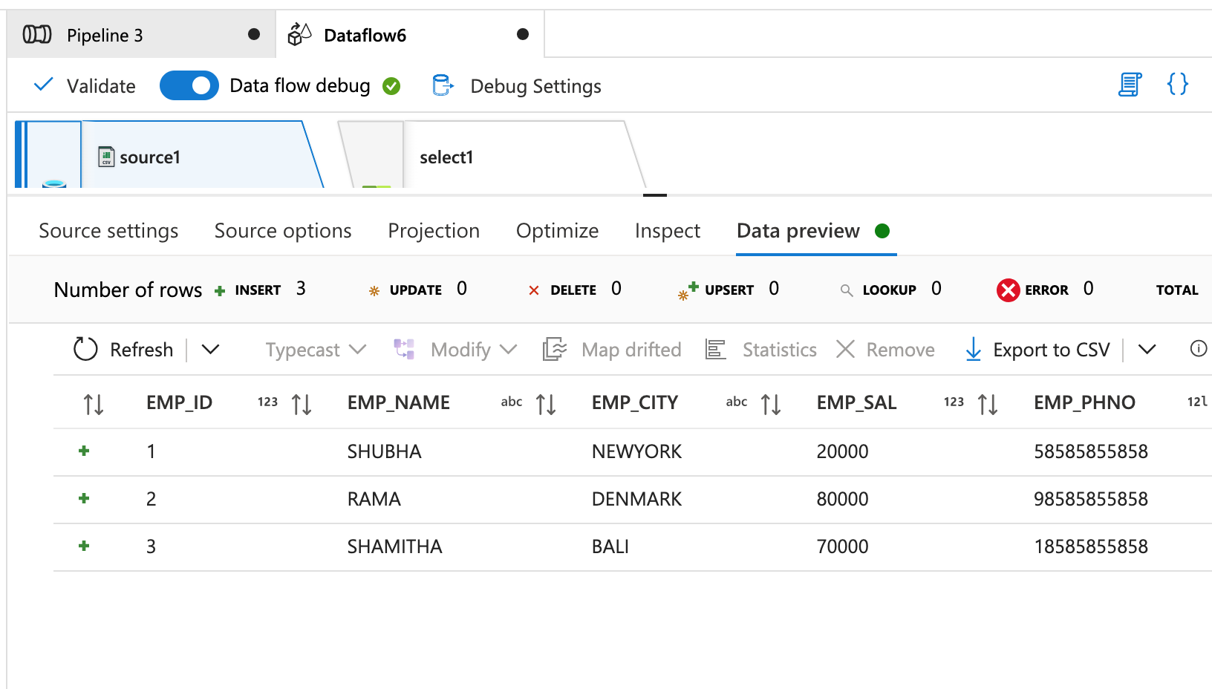 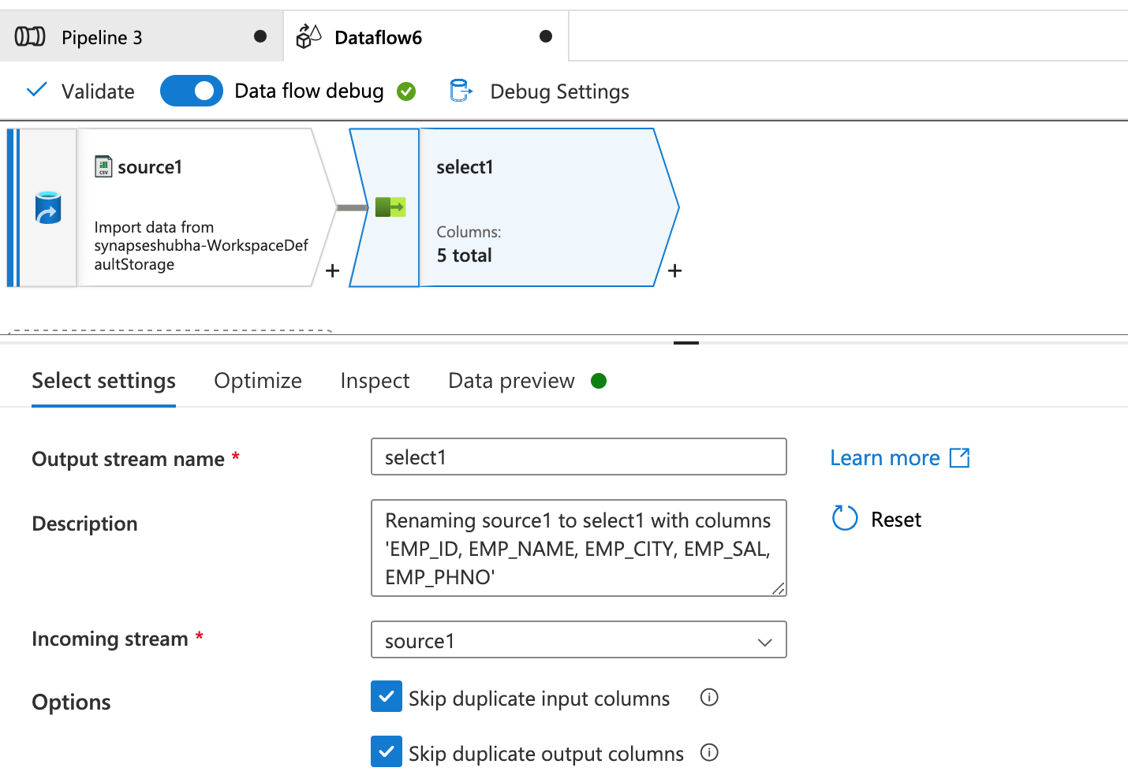 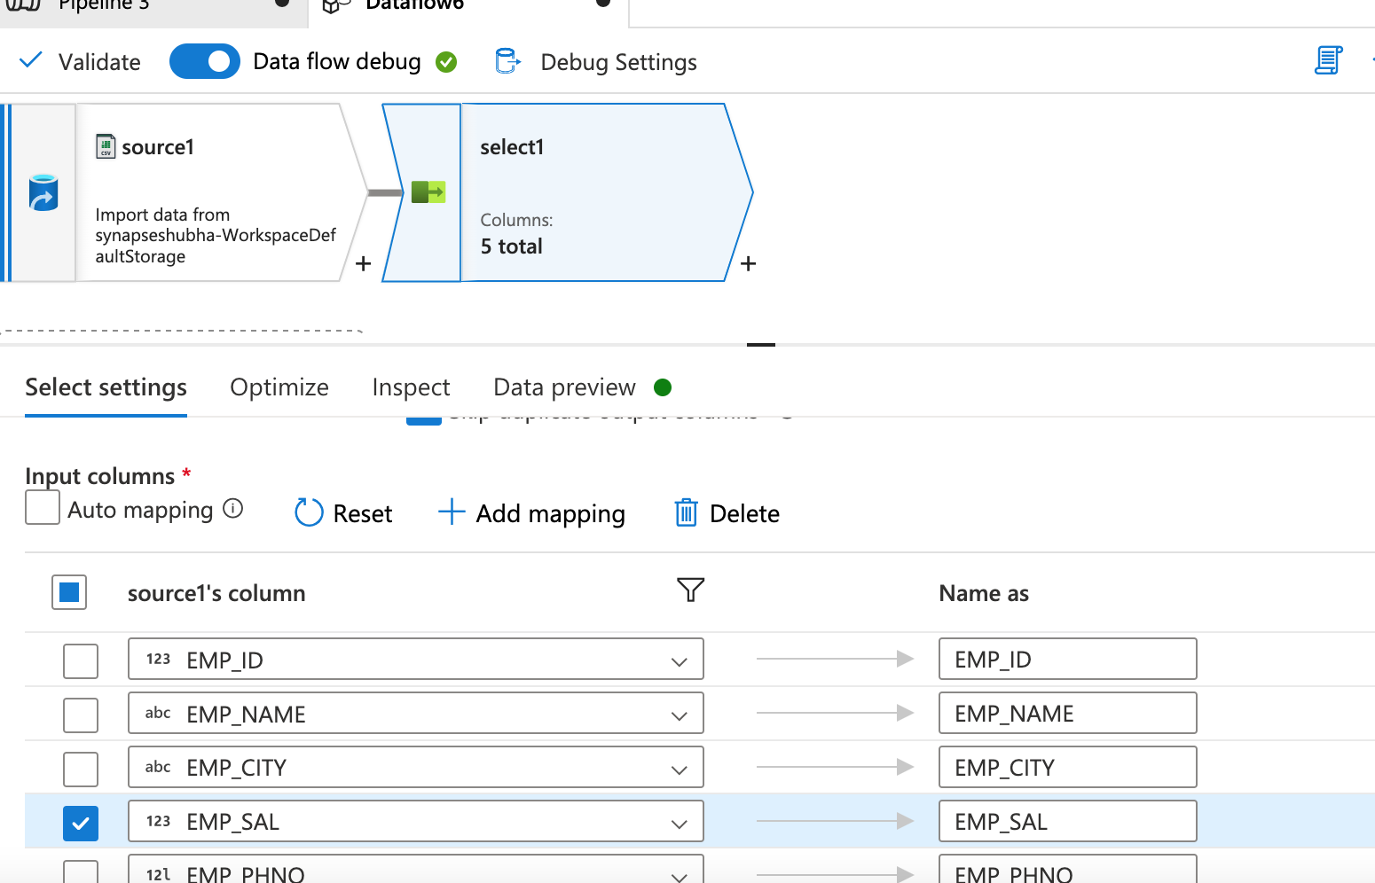 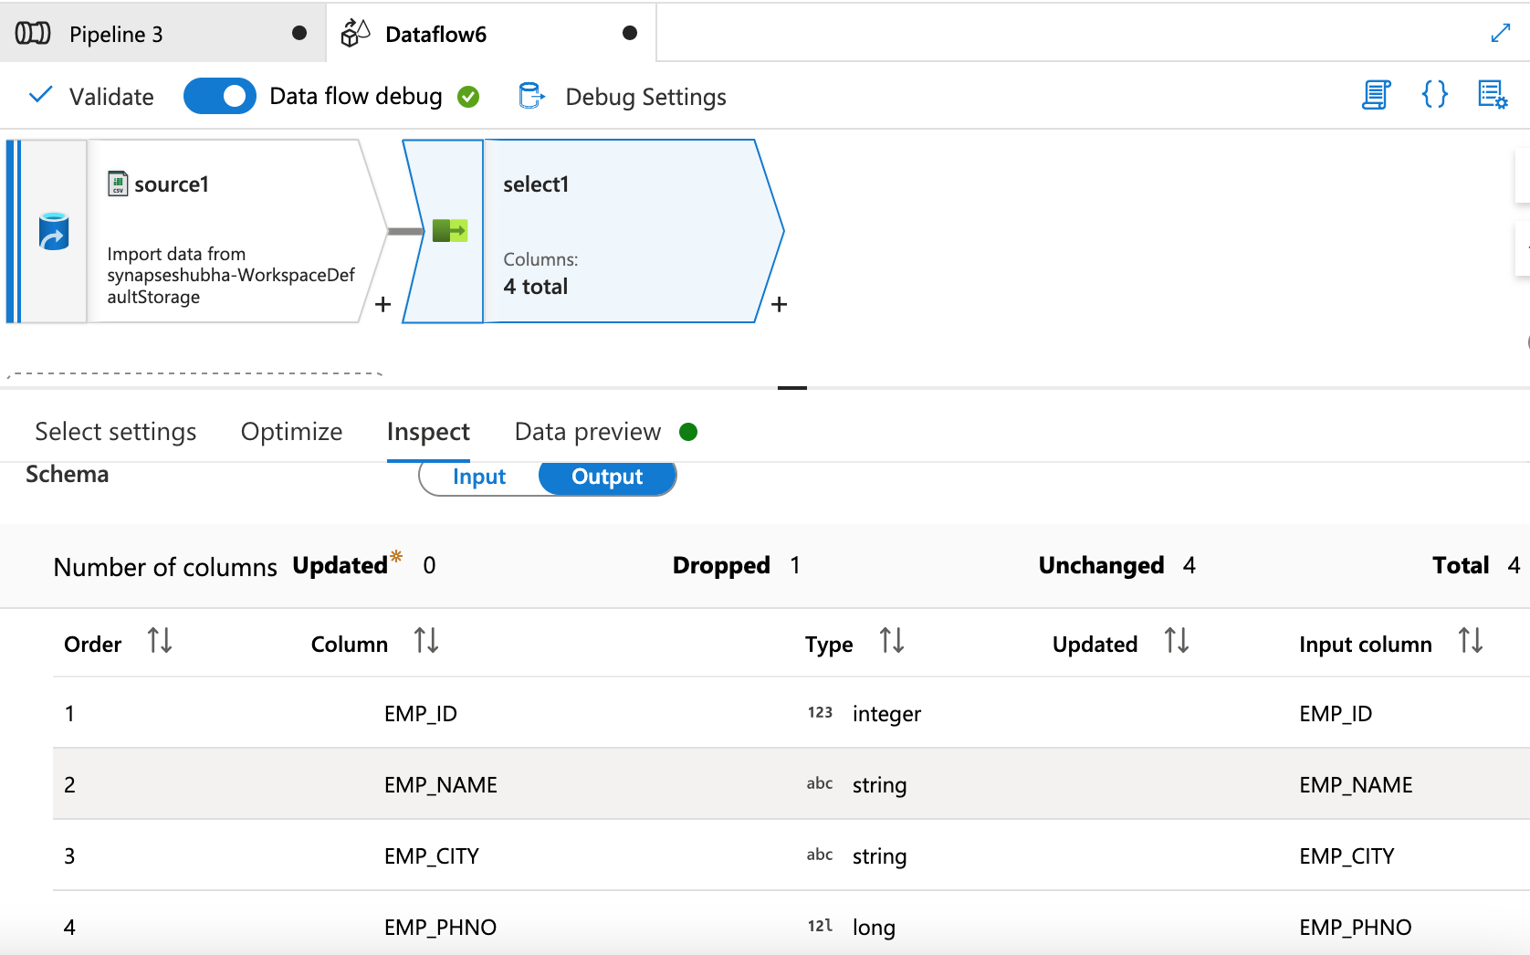 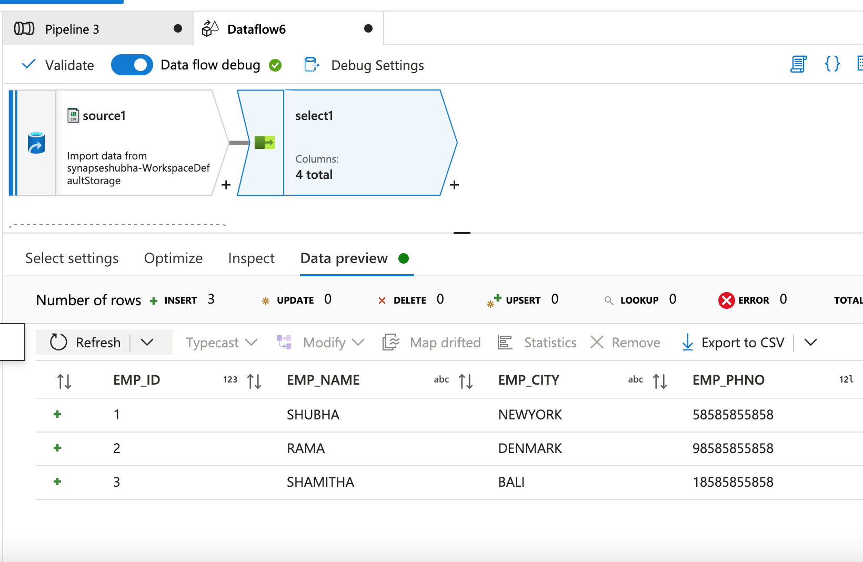 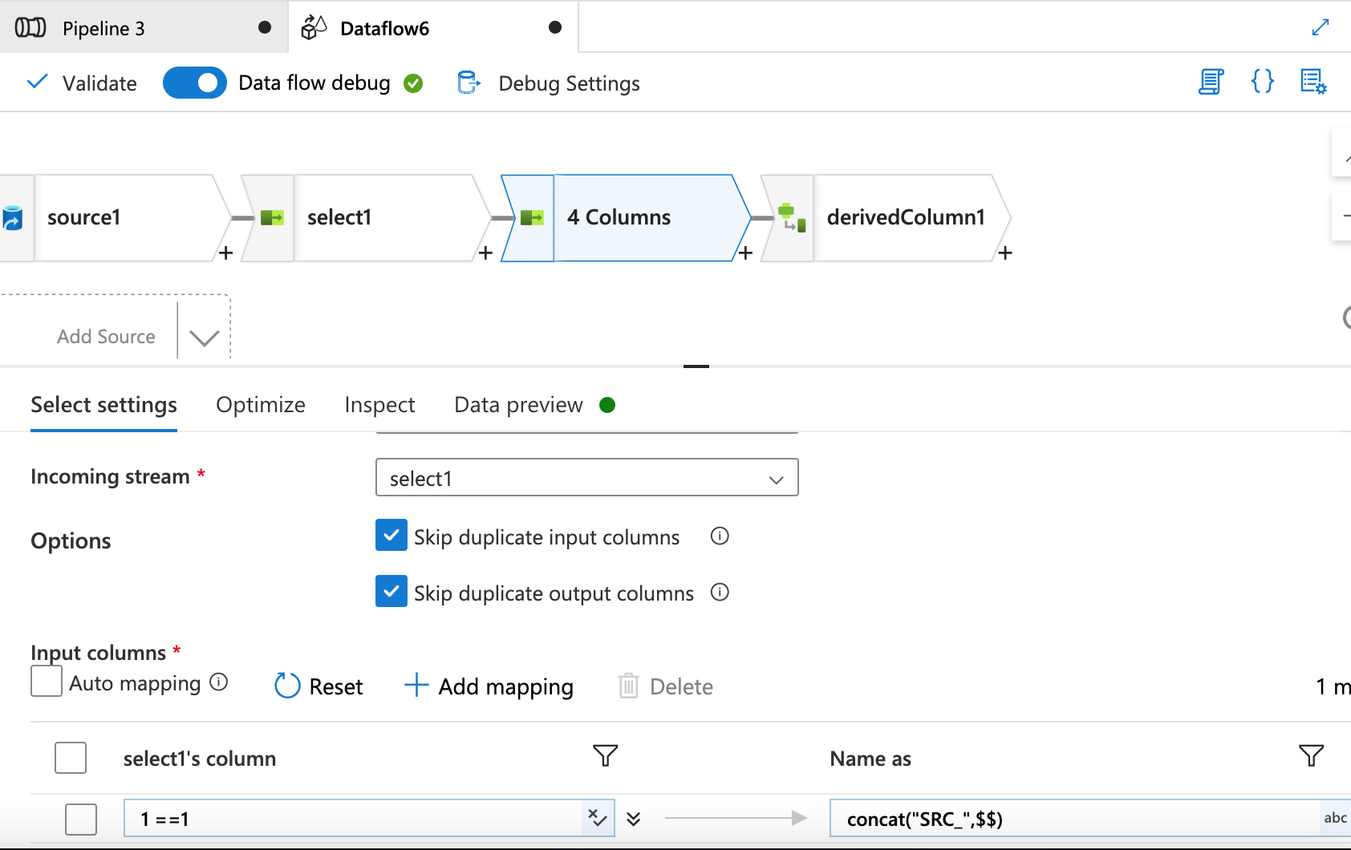 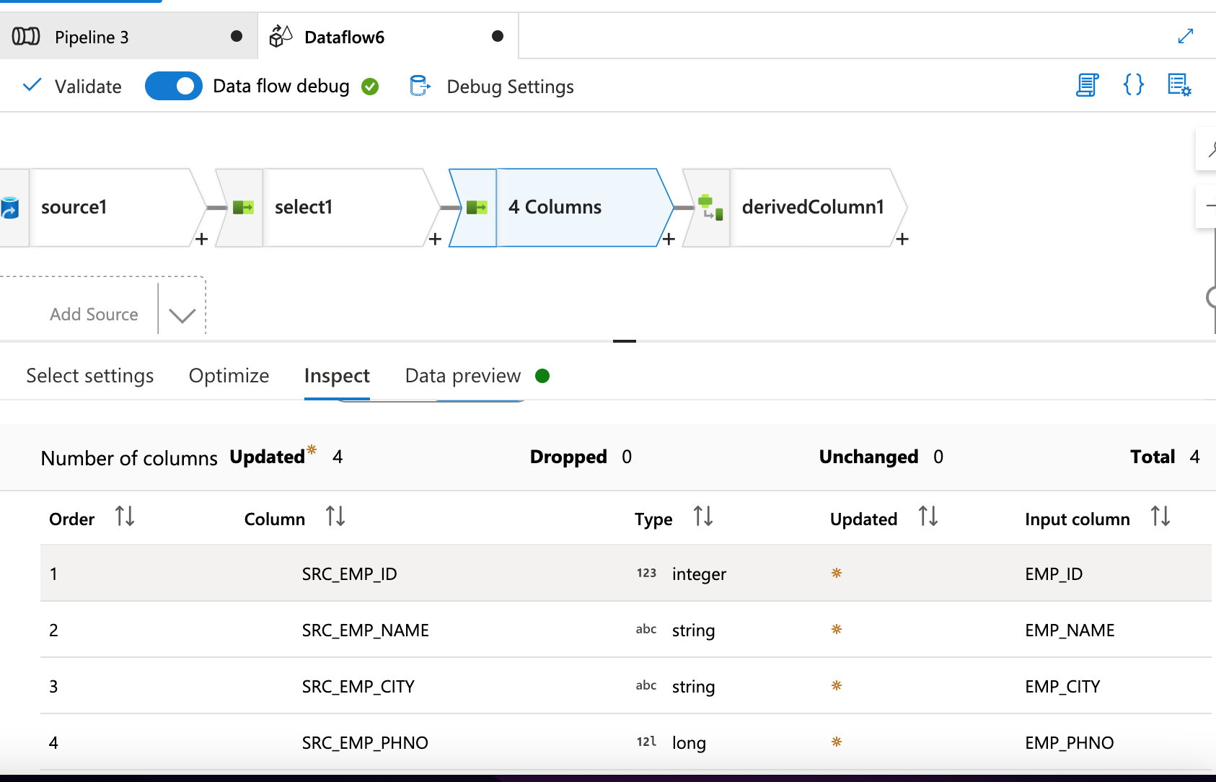 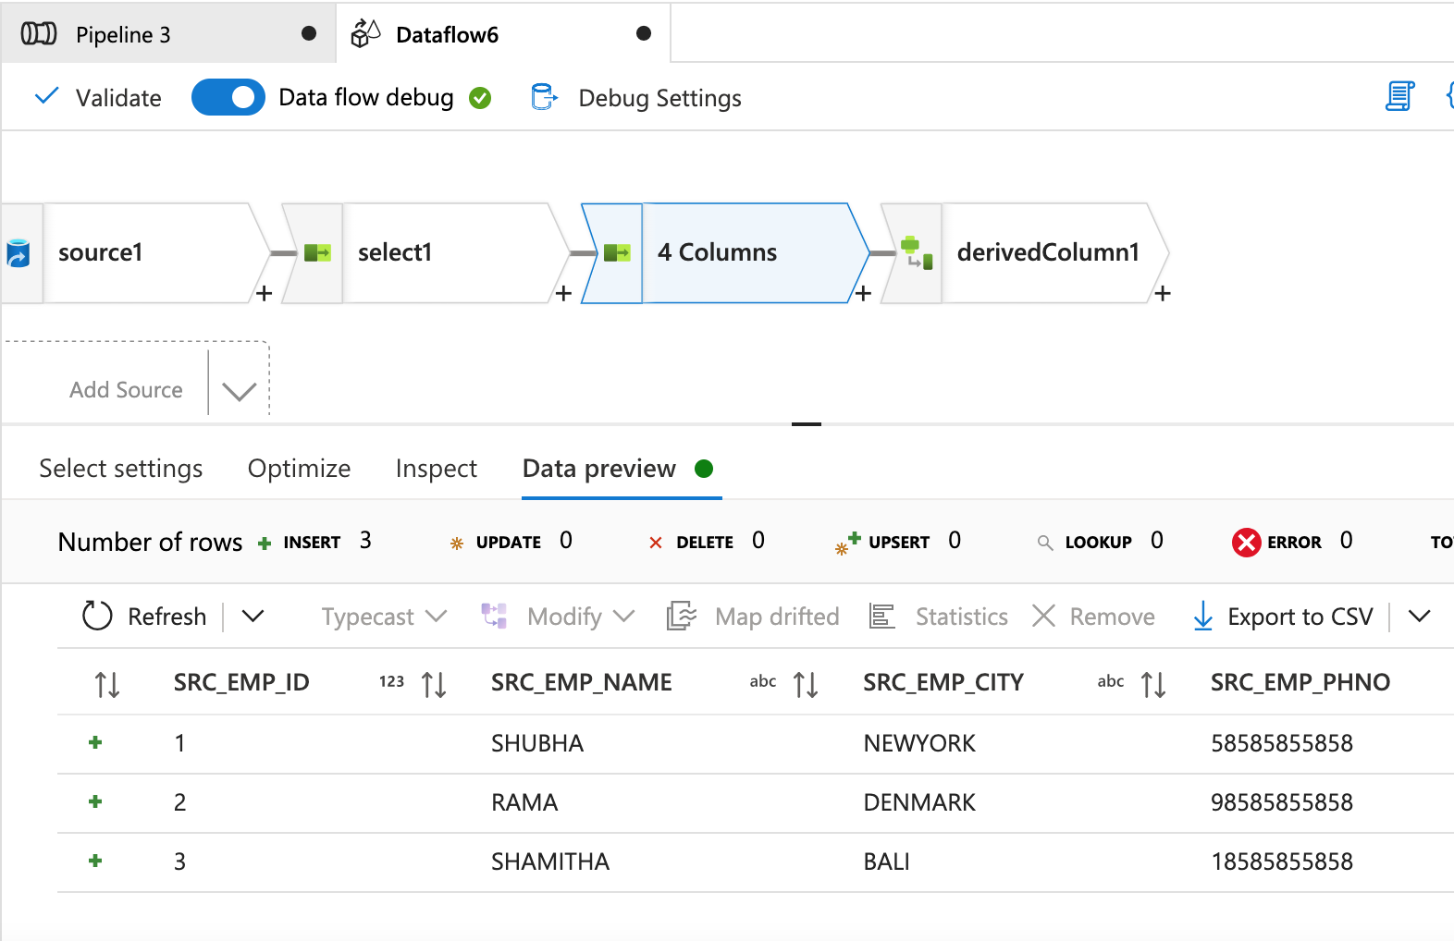 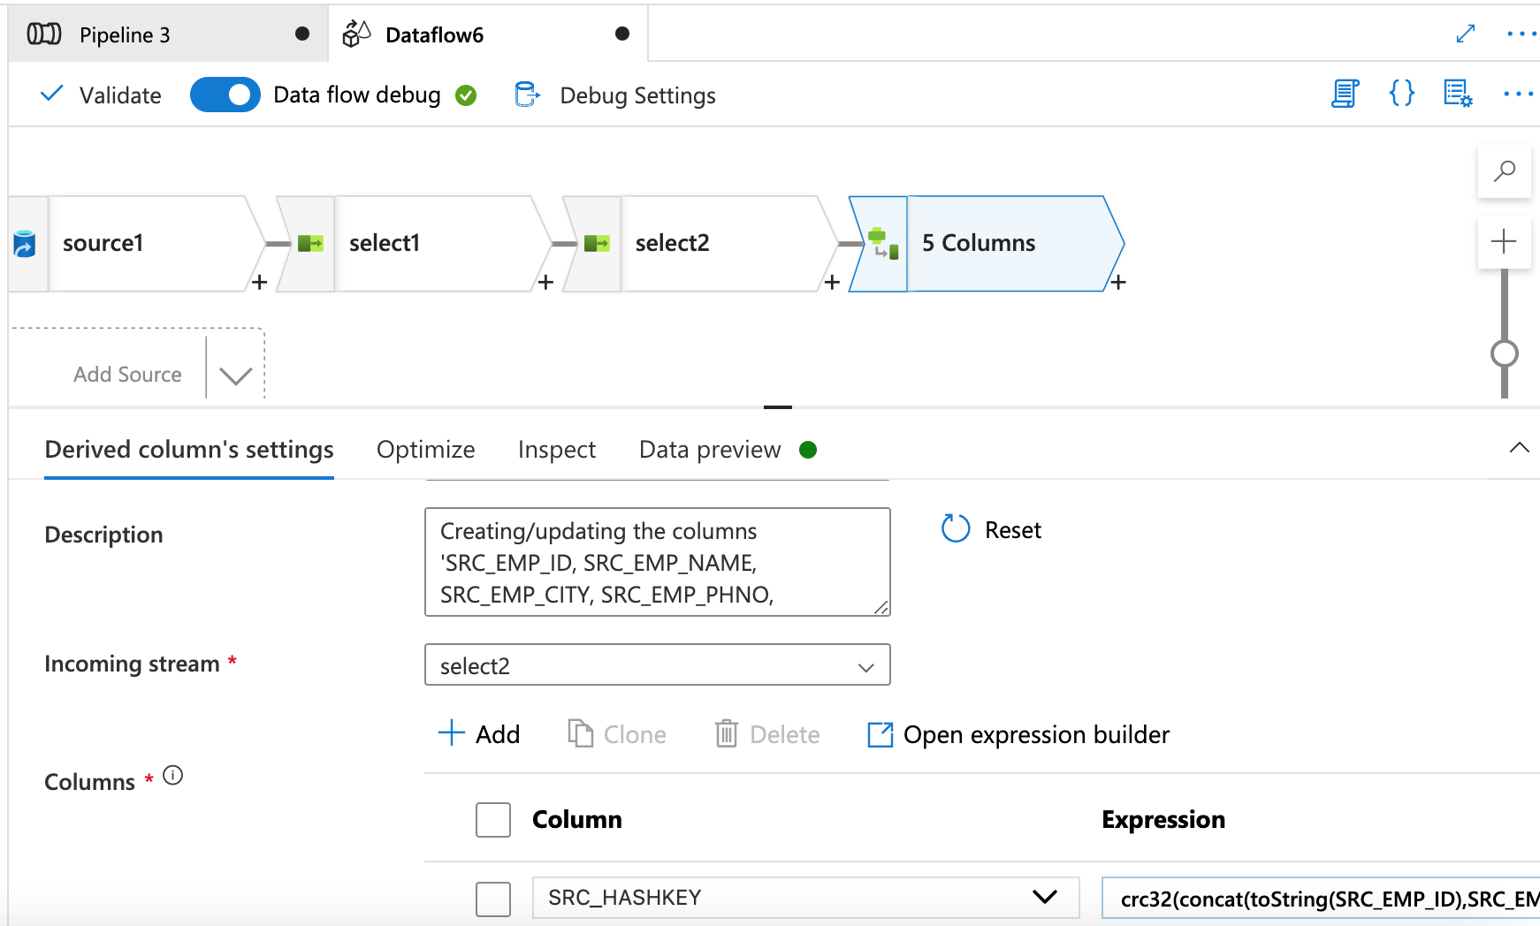 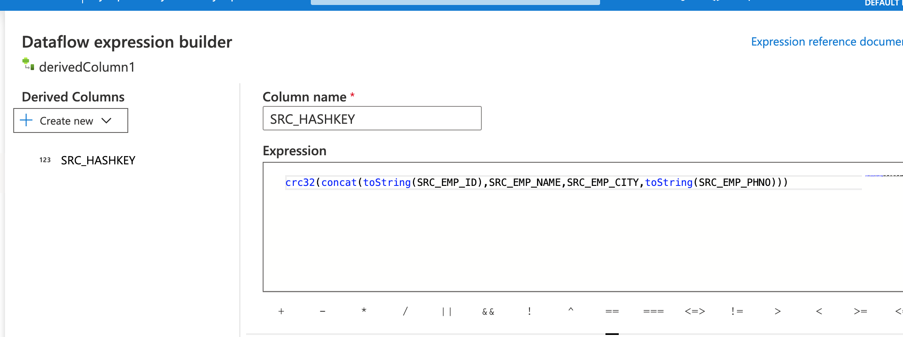 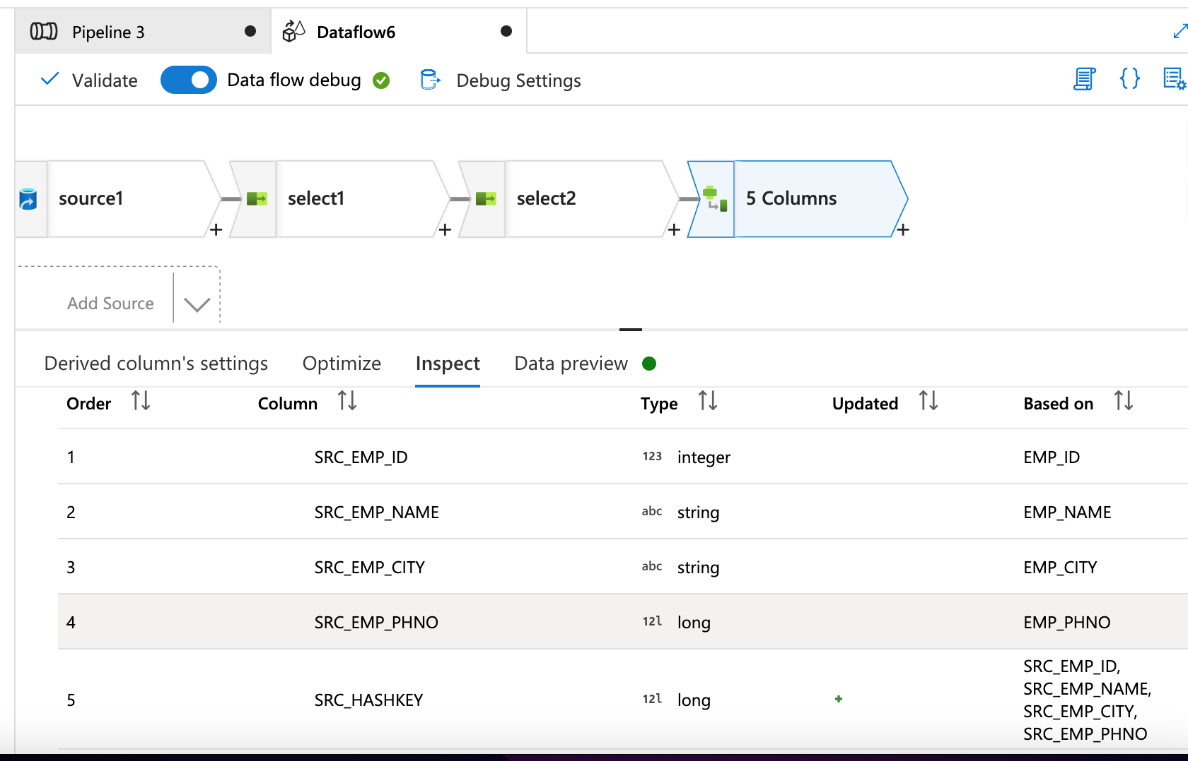 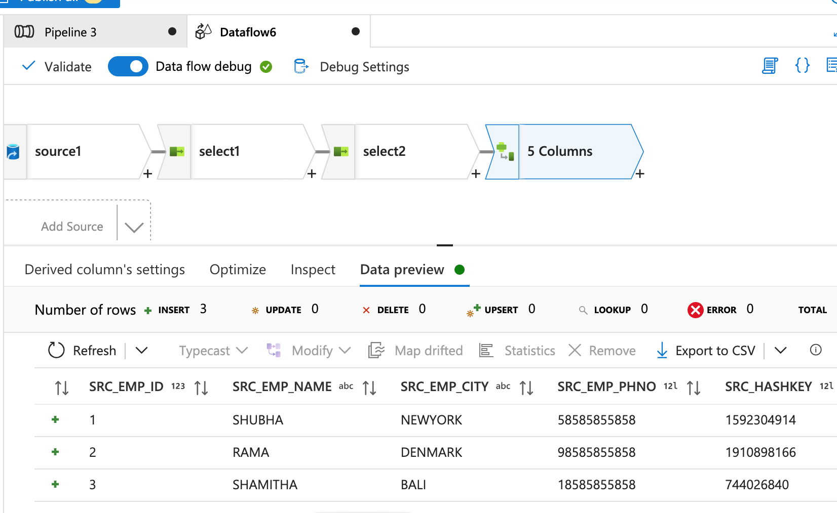 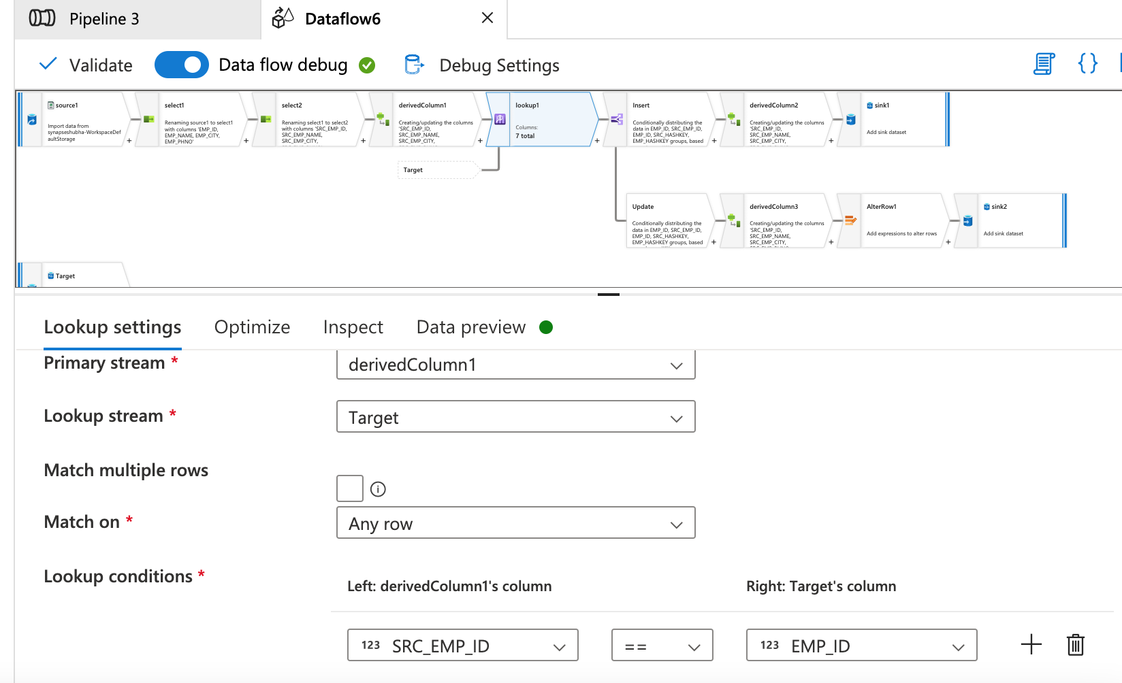 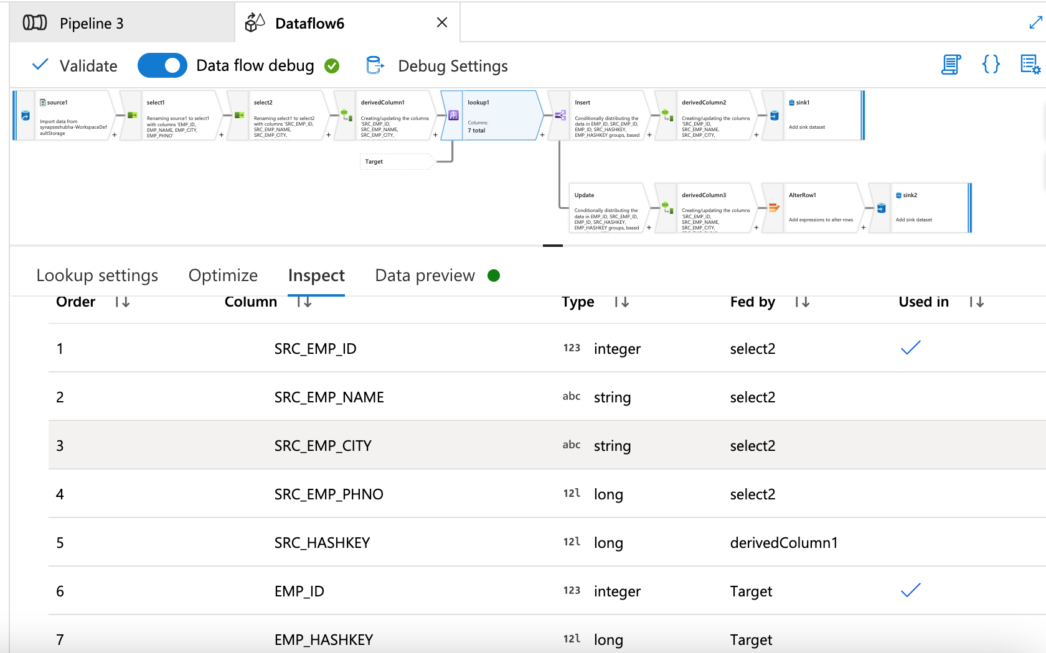 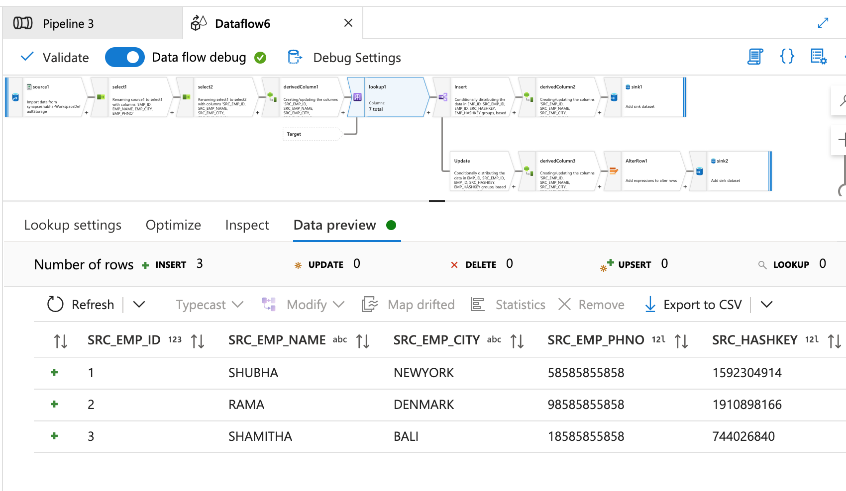 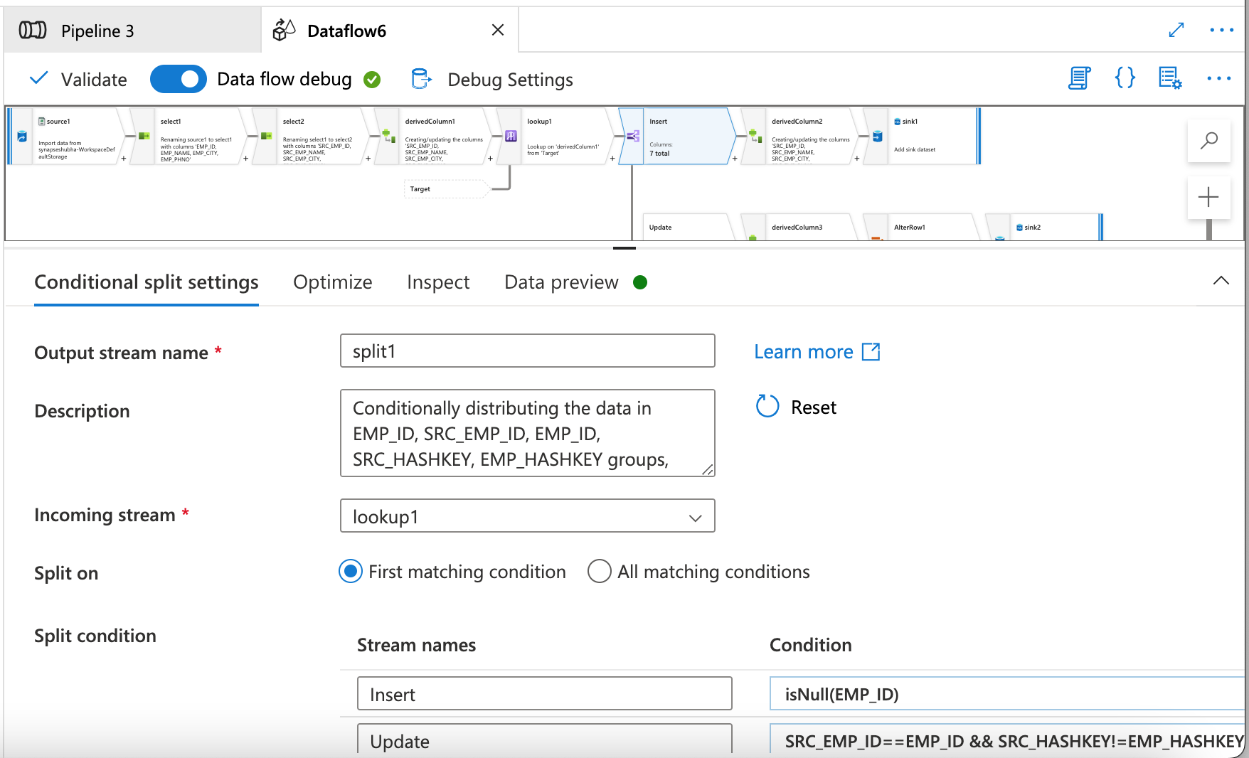 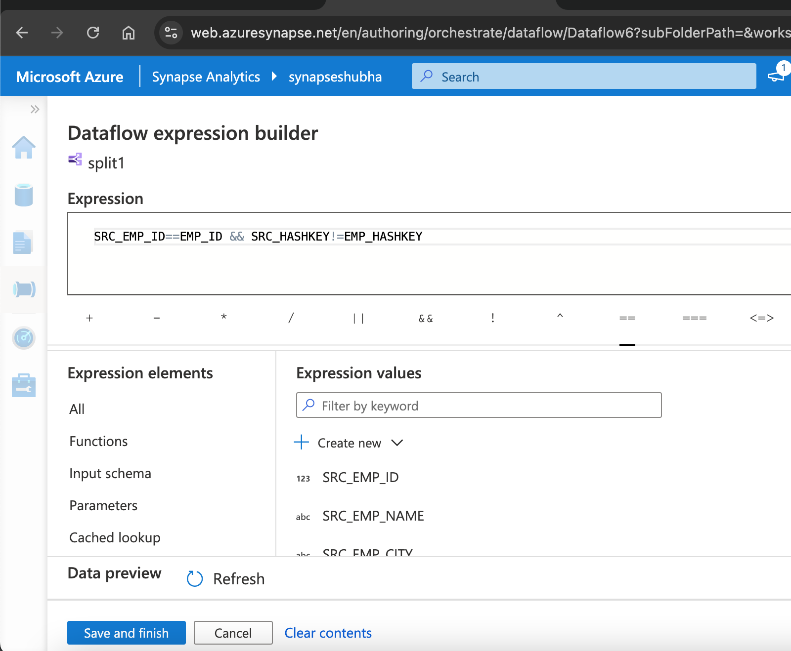 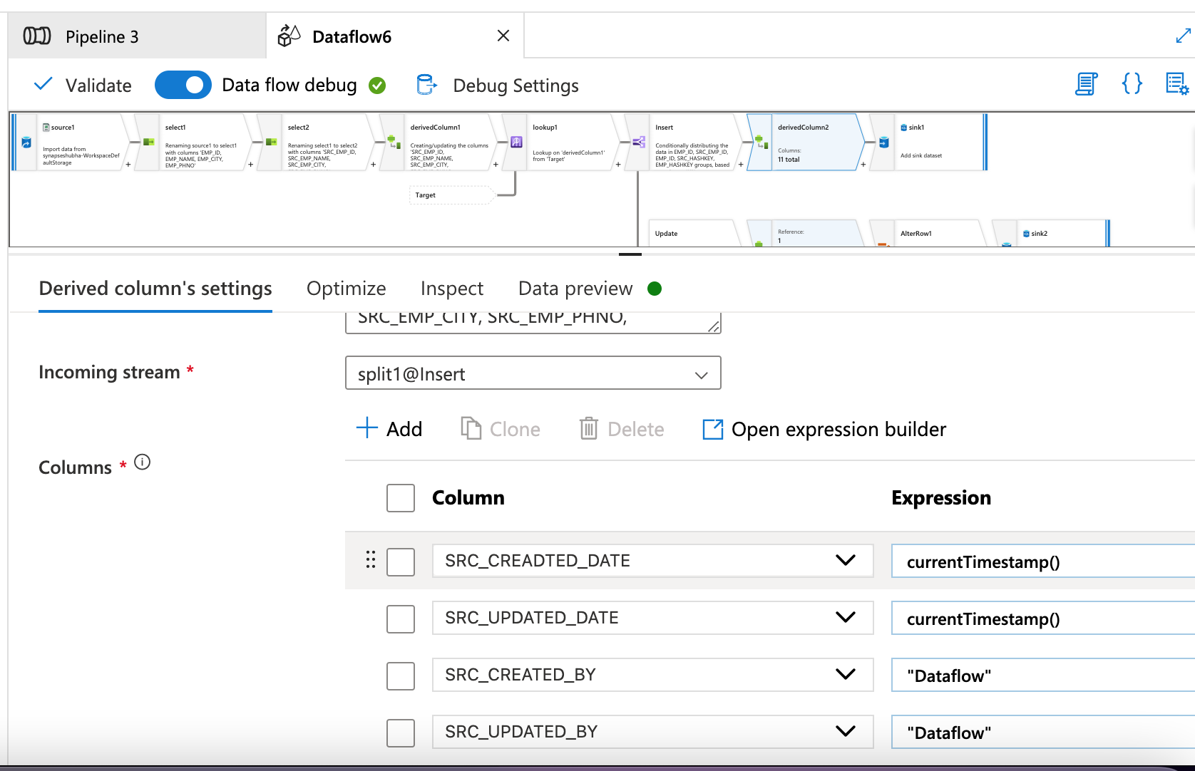 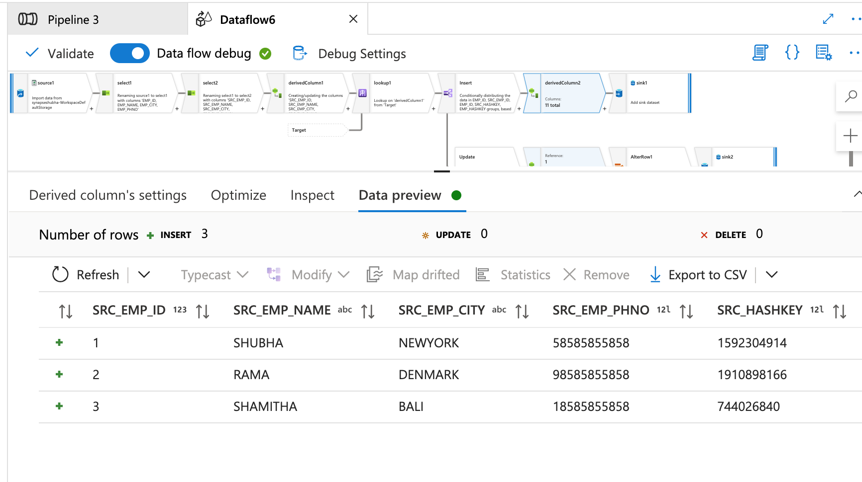 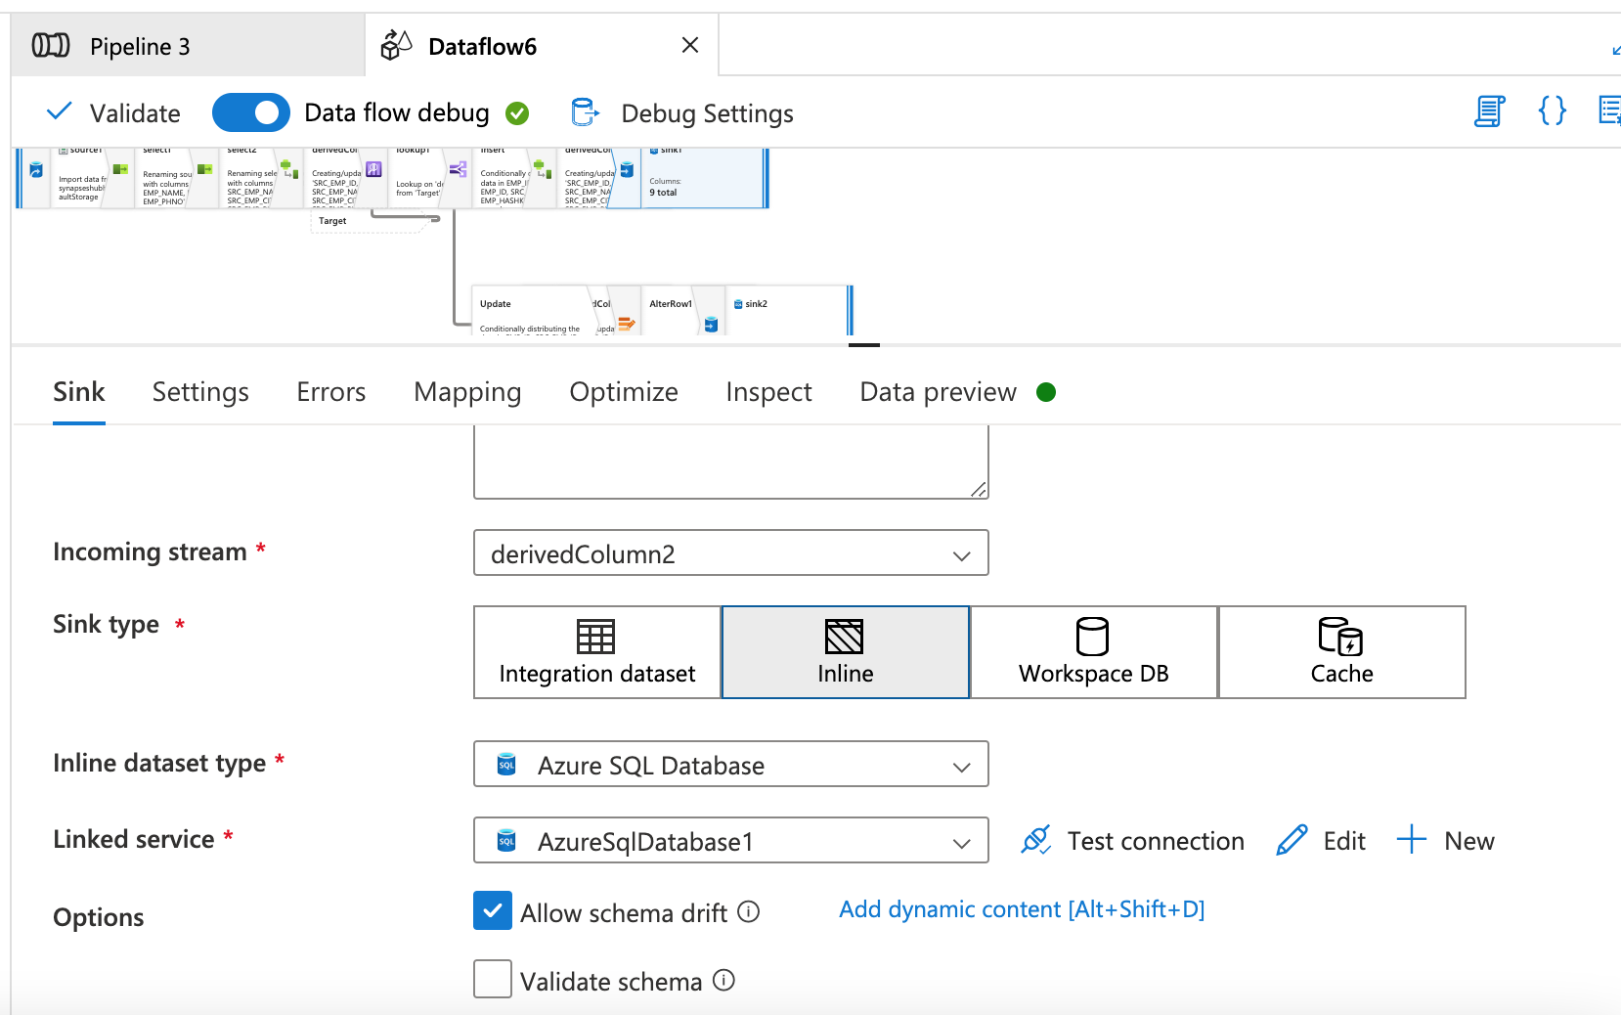 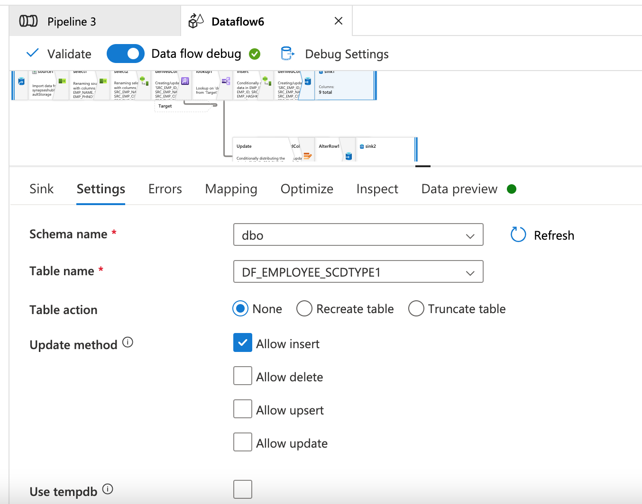 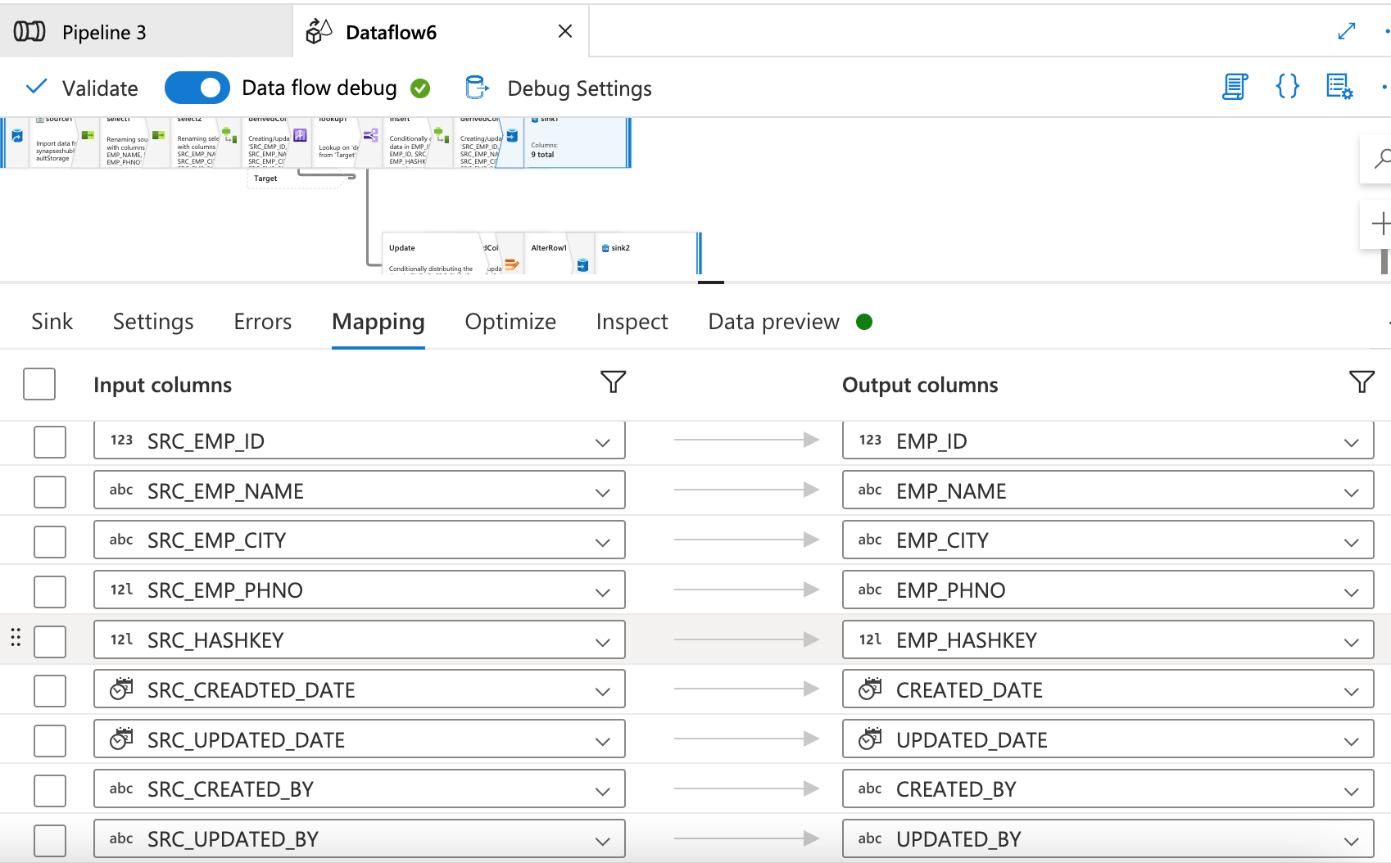 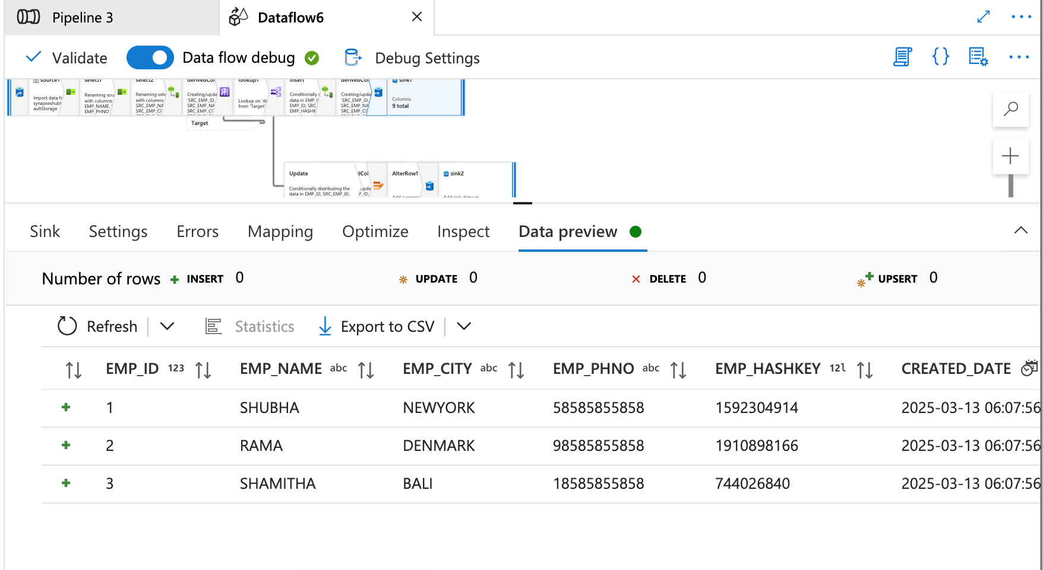 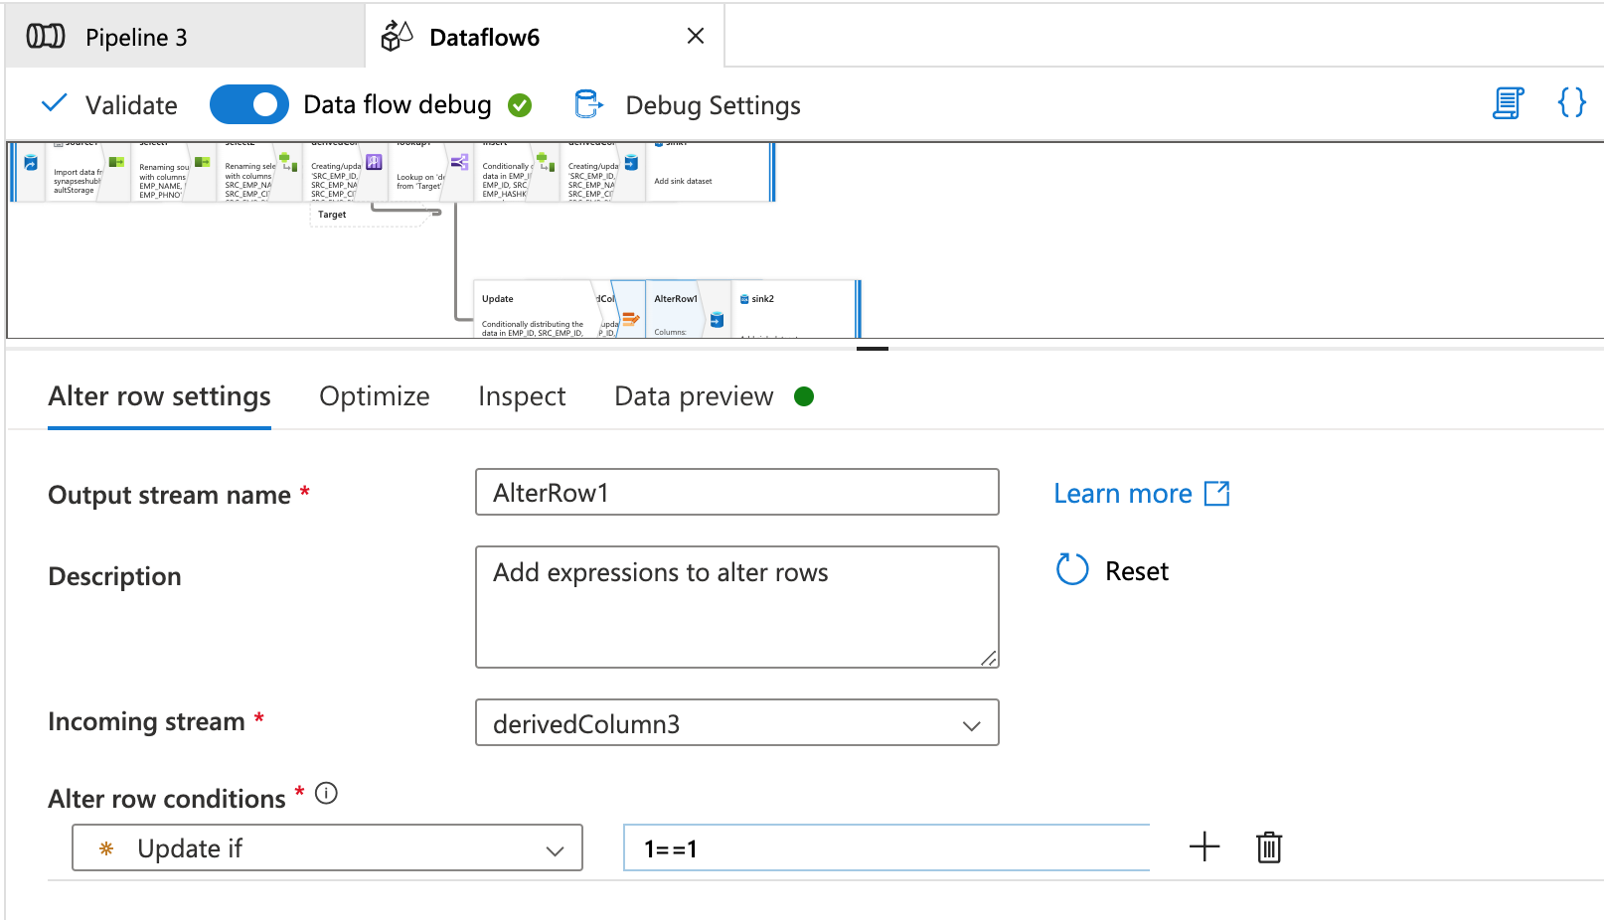 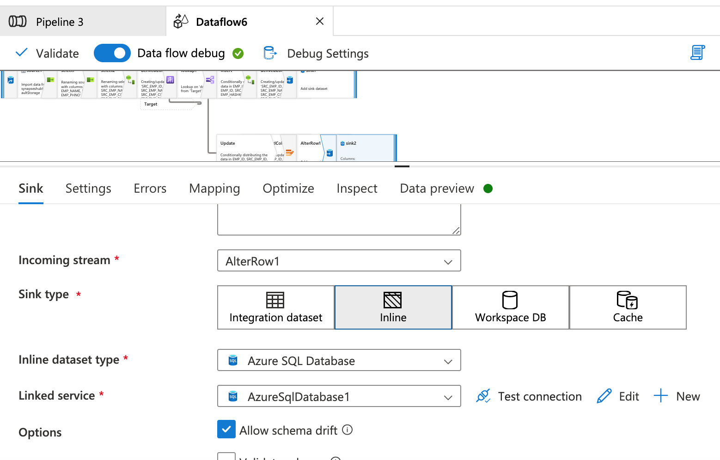 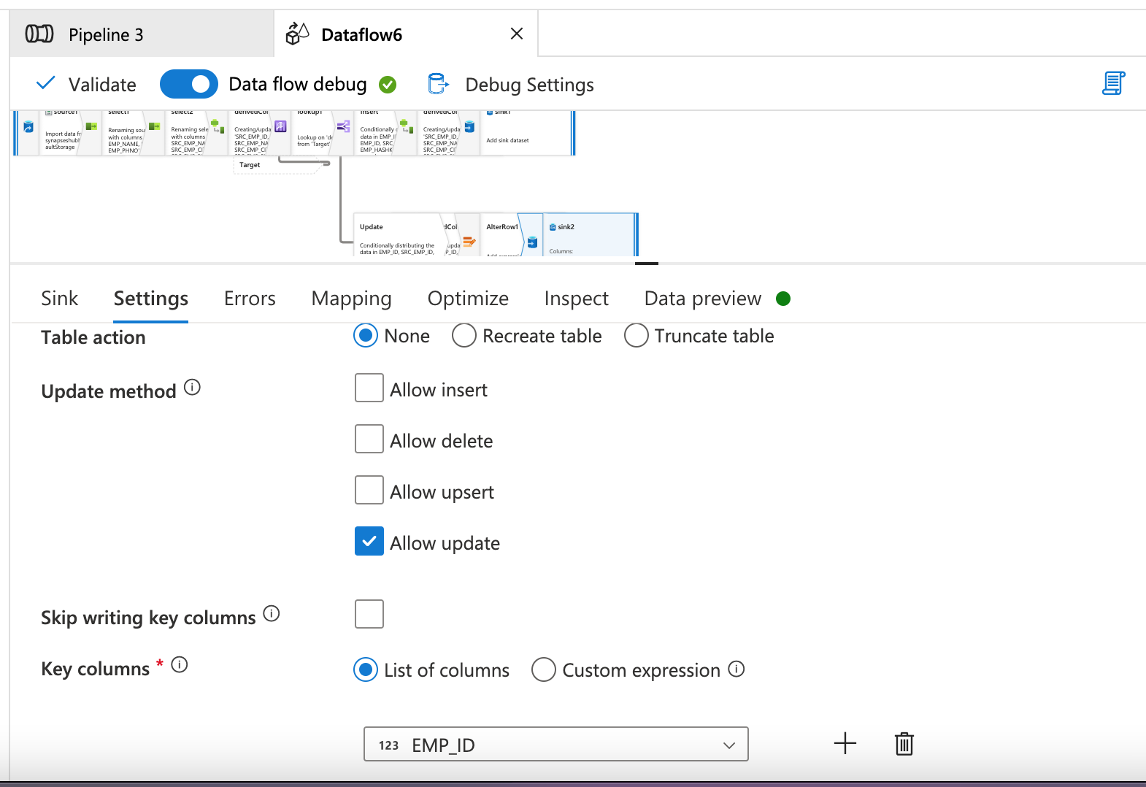 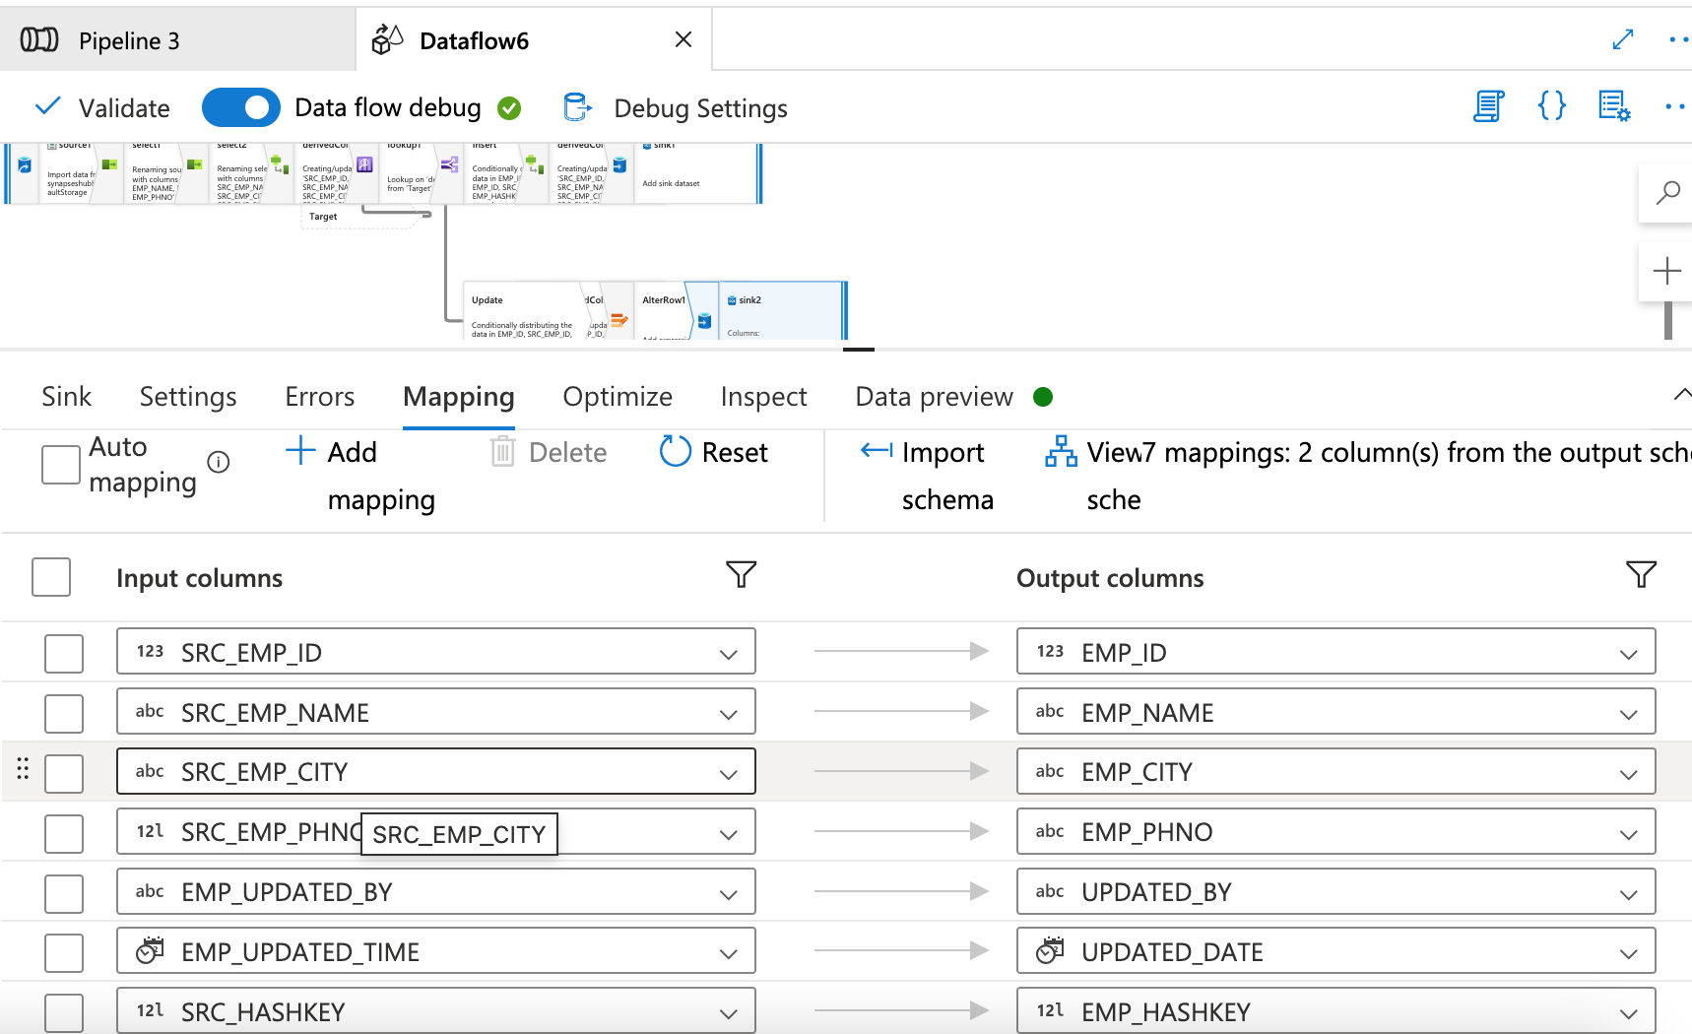 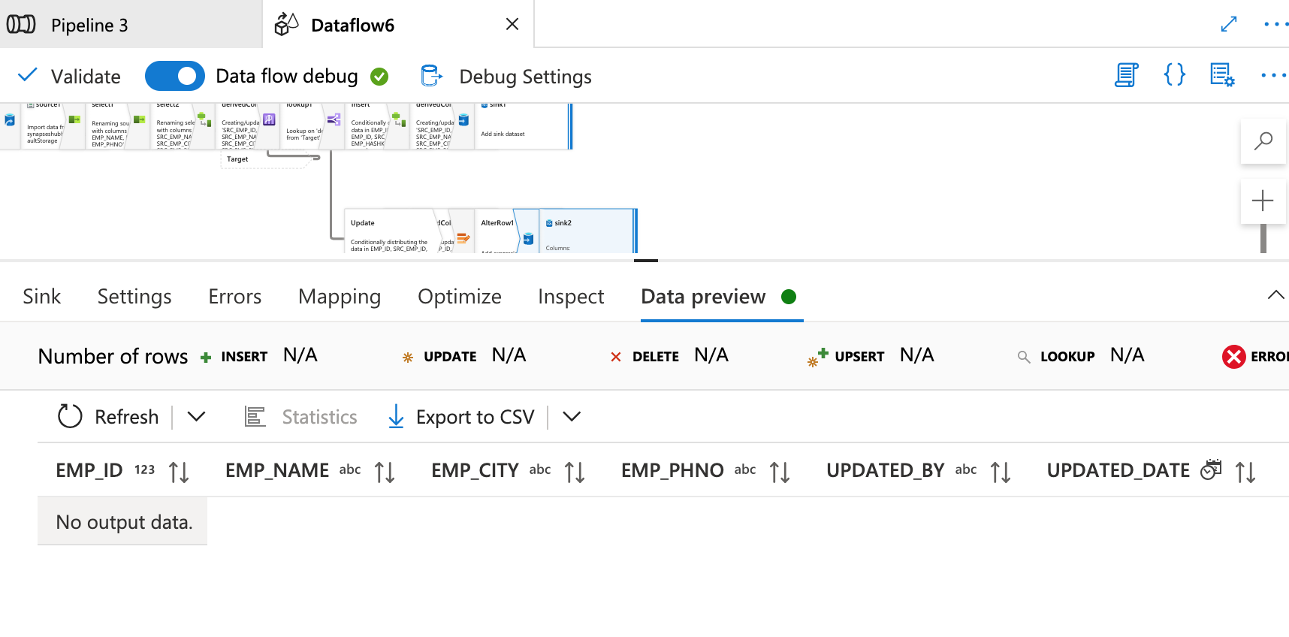 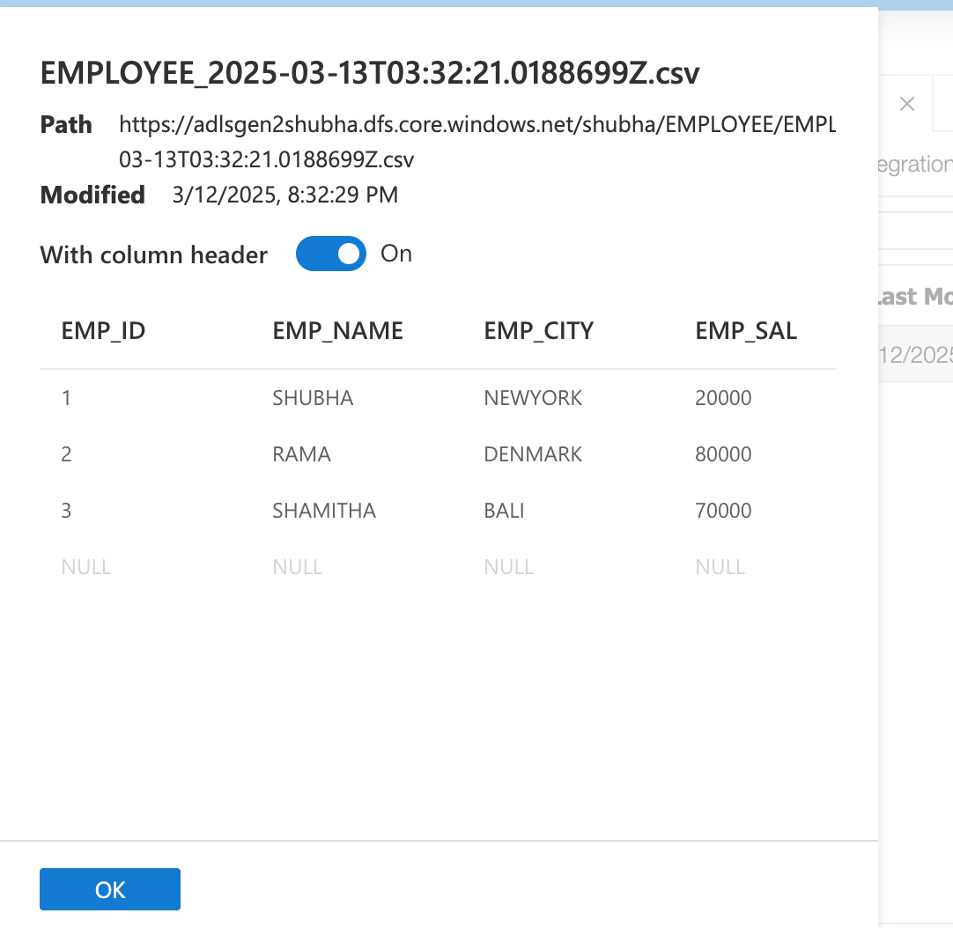 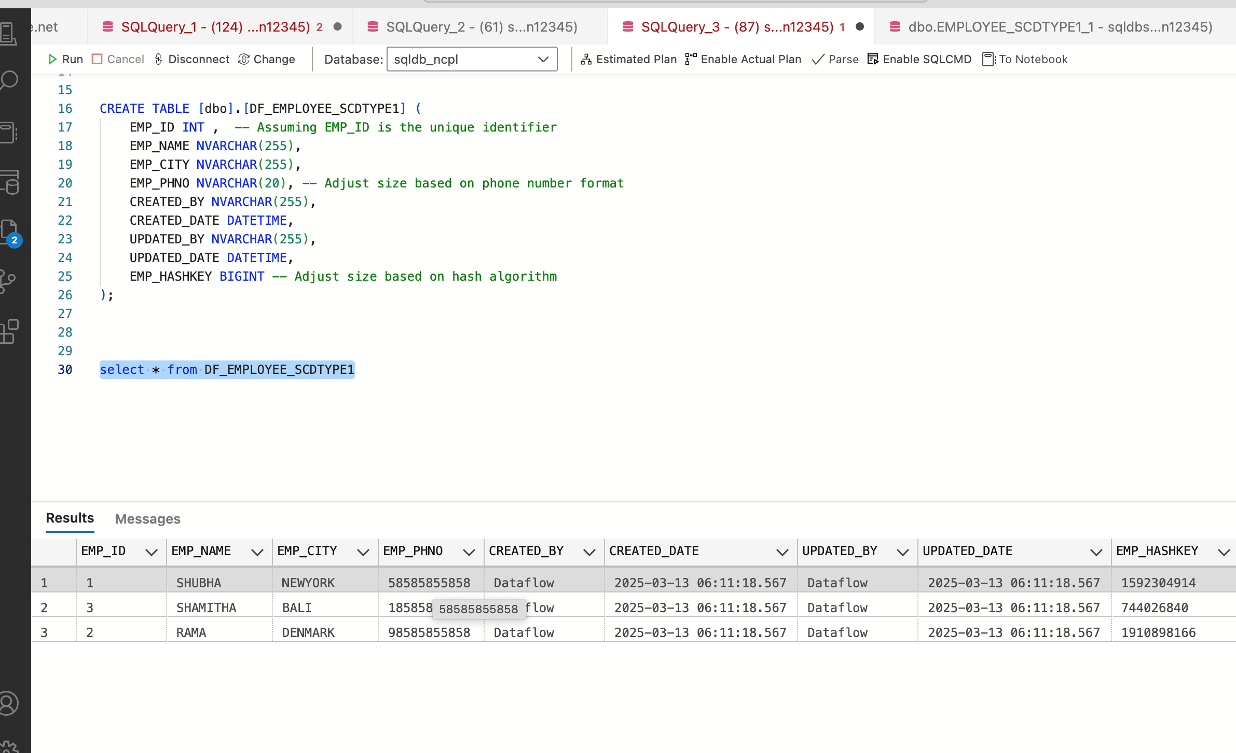 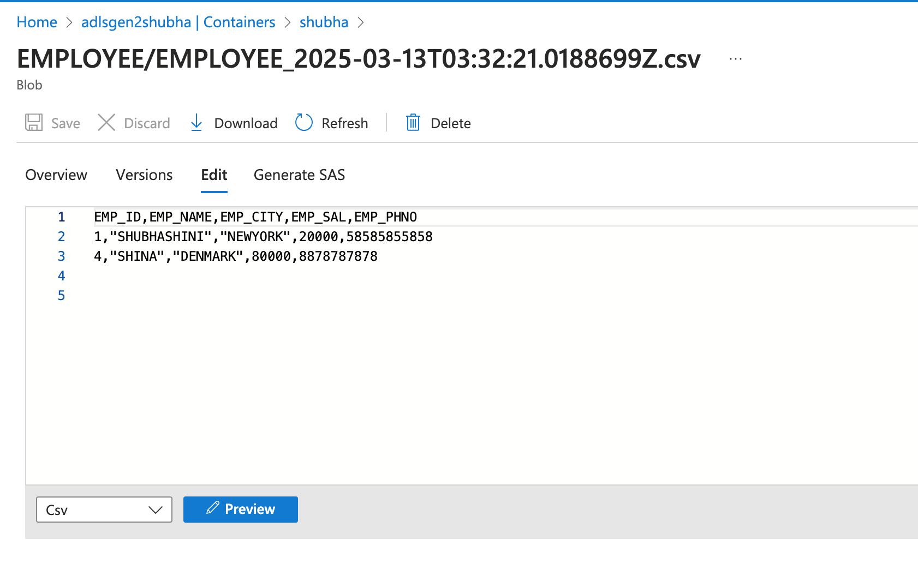 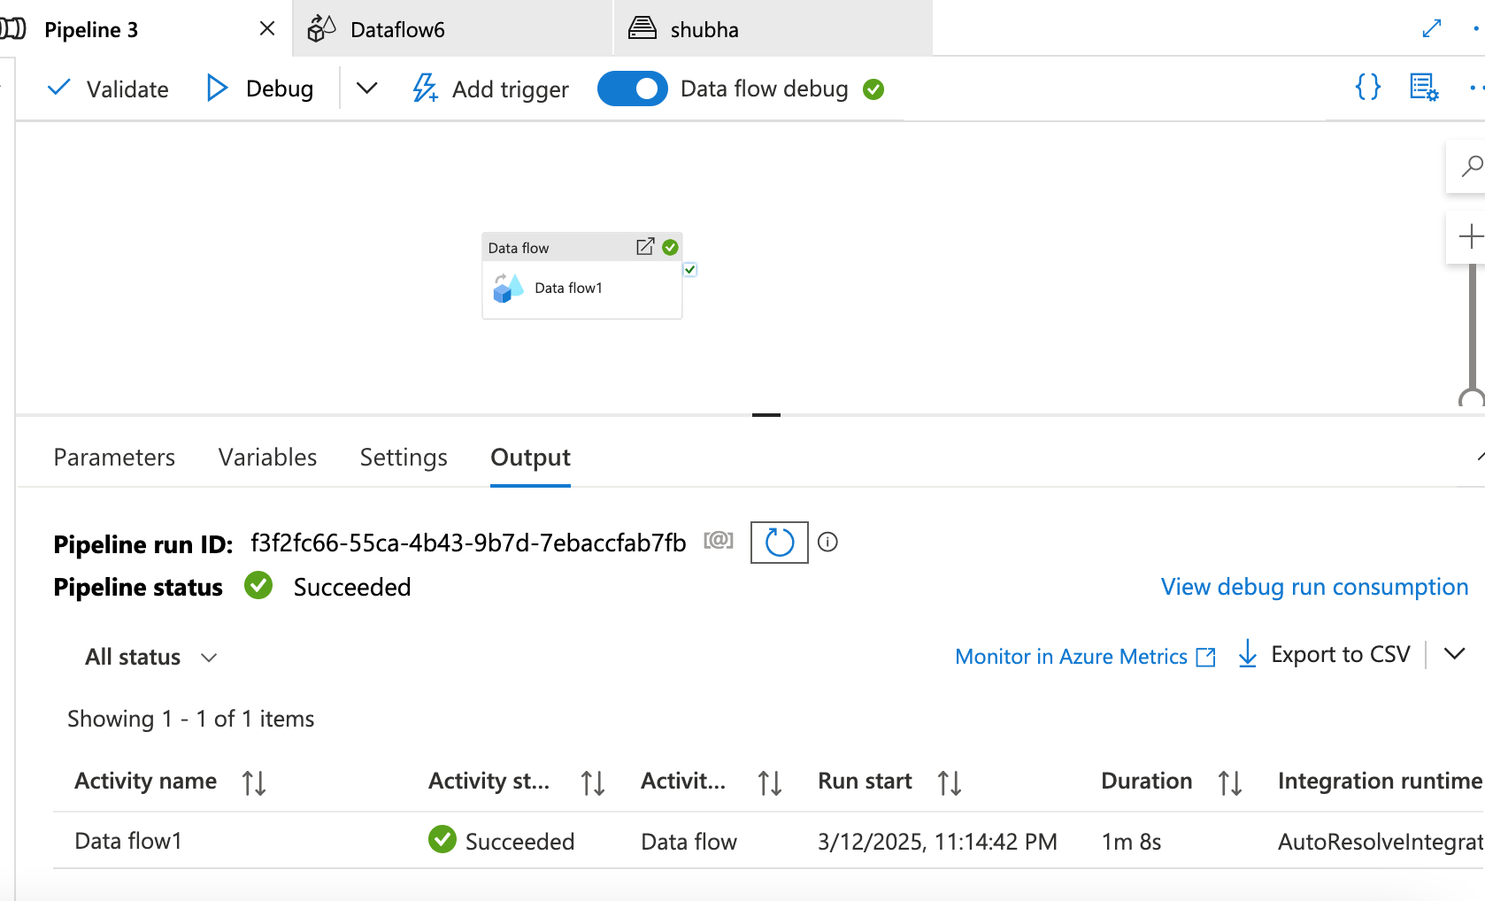 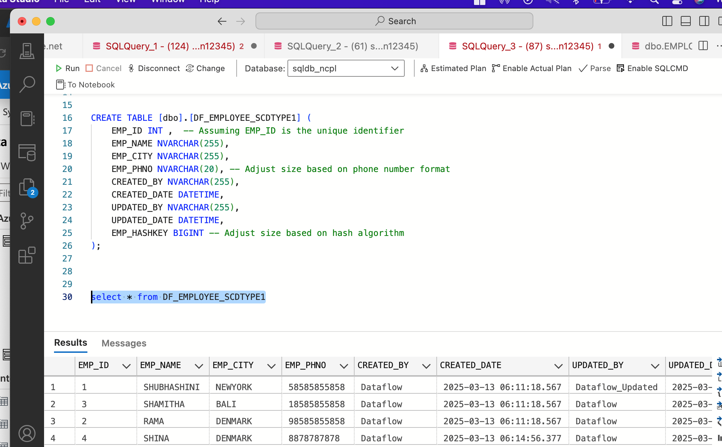

SCD Type2:

